Table of Contents
Section 1
Flight Standardization
- Flight Training Outline………………………………………………………………………….…………Page 3
- Required Student Documents…………………………………………………………..…………….Page 3

Section 2
Pre Flight Information

- Aircraft Specifications…………………………..…………….…………………………….…………….Page 4
- Inspection Requirements & Acronyms …………………………………………….…..…….... Page 7
- IFS Standards…………………………………………………………………..…………….…….………....Page 8

Section 3
The Flight Environment
- The Garcon Transition Departure & Beach Practice Area…………………… ….…..… Page 9
- The North-West Practice Area & Bay Minette Airport …………………………………... Page 11

Section 4
The Flight Lessons
- Flight Lesson 1…………………………………………………………………………………….…………. Page 12
- Flight Lesson 2……………………………………………………………………………………………......Page 13
- Flight Lesson 3……………………………………………………………….…………………………………Page 14
- Flight Lesson 4……………………………………………………………….…………………………………Page 15
- Flight Lesson 5………………………………………………………….………………………………………Page 16
- Flight Lesson 6……………………………………………………………….…………………………………Page 17
- Flight Lesson 7…………………………………………………………….……………………………………Page 18
- Flight Lesson 8A………….………………….…………………………………………………………………Page 19
- Flight Lesson 8B…………………………………………………………………………………….………….Page 20
- Flight Lesson 10………………………………………………………………………………………………..Page 21
- Flight Lesson 9……………..……………………………………….………………………………………….Page 22

Section 5
Flight Procedures

- Normal Takeoff and Climb…………………………………………………………………….……….….Page 23
- Crosswind Takeoff and Climb………………………………………………………………..………....Page 23
- Level Off…………………………………………………………………………………………………………….Page 24
- Aborted Takeoff………………………………………………………………………………….………….…Page 24
- Normal Approach and Landing…………………………………………………………….……….……Page 24
- Crosswind Approach and Landing………………………………….……………………….…….……Page 25
- Go Around and Rejected Landing………………………………………………………….……….….Page 25
- Emergency Approach and Landing …………………..…………………………………..…..…….…Page 26
- Traffic Pattern……………………………………………………………………………………………….……Page 27
- Forward Slip……………………………………………………………………………………..……….…….…Page 28
- Side Slip………………………………………………………………………………………………….……….…Page 28
- Slow Flight Dirty…………………………………………………….……………………………….…..……..Page 29
- Slow Flight Clean…………………………………..……………..…………………………………….……..Page 30
- Power Off Stall………………………………………………………………………….……………..…….….Page 31
- Power On Stall……………………………………………….………………………………………..…..…….Page 32
- Steep Turns…………………………………………………………………….……………………….………..Page 33
- Turns About A Point……………………………………………………….……………………….…………Page 34
- Rectangular Course………………………………………………………………………………….…..…..Page 35
- S-Turns………………………………………………………………………………….…………..…….…………Page 36
- Unusual Attitude Recovery………………………………………………………………….….………..Page 37

Section 6
Student Information
- Radio Call Examples…………………………………………………………………………….….………….Page 38
- Oral Exam Questions………………………………………….…………………………………….………..Page 41
- Airport Diagram…………………………………………………………………………………….….………..Page 42
- Told Card…………….…………………..………………………………………………………………..……….Page 43
- Told Card Instructions…………………………………………………………………………………………Page 44
- Wind Component Chart……………………………………………………………………..………………Page 46

FLIGHT TRAINING OUTLINE
The chart below is a brief description of each flight, the corresponding flight times and brief times as well as landing minimums. It is imperative that the instructor look to see that the student is on track with their corresponding times and landings for each lesson. If students are ahead or behind on the total flight time and or landings please adjust accordingly, if you have any questions regarding this subject please feel free to consult the chief flight instructor.
FLIGHT | DESCRIPTION | GROUND BRIEF (HRS) | FLIGHT TIME (HRS) | STUDENT TOTAL HOURS PRE-FLIGHT | MINIMUM LANDINGS  PER FLIGHT
1 | Basic Flight | 1.0 | 1.0 | 1.0 | 2
2 | Pattern/Landings | 1.0 | 1.0 | 2.0 | 2
3 | Stalls/Slow Flight | 1.0 | 1.0 | 3.0 | 2
4 | Emergency Procedures | 1.0 | 1.5 | 4.5 | 5
5 | Ground Reference | 1.0 | 1.5 | 6.0 | 5
6 | Slips/Go-Around’s | 1.0 | 1.5 | 7.5 | 5
7 | Lessons Review | 1.0 | 1.5 | 9.0 | 5
8A | Mock Check Ride | 1.0 | 1.5 | 10.5 | 5
8B | Check Review/Landings | 1.0 | 1.0 | 11.5 | AS REQUIRED  (MUST have 30 total at end of this flight)
10 | Stage 1 Check | 1.5 | 1.5 | 13.0 | AS REQUIRED
9 | Safe to Solo/Solo | 1.0 | .5 w/ instructor &  .5 Solo | 13.5 (Total w/Instructor)  .5 Solo | 3 WITH INSTRUCTOR  3 SOLO

REQUIRED STUDENT DOCUMENTS
Required before flight 1
- Driver’s license and birth certificate or passport. (Need complete before first flight.)
- Instructor signed TSA label.
- Third class medical certificate.
Required before solo flight
- All instructor logbook and medical endorsements.
- Student Pilot Certificate (or Temporary from FAA)

AIRCRAFT SPECIFICATIONS
- INSTRUCTOR WEIGHTS – For TOLD card purposes use 180 pounds as both your instructor weight as well as any backseat passenger.
- AIRPLANE SPECIFICATIONS – Find your aircraft below and fill out the corresponding information to complete your TOLD card.
- KNOTS/MPH – Please note that some of the Airspeed Indicators are in knots and some are in miles per hour. The basic conversation is 1 Knot = 1.15 MPH
 | CESSNA 172
- FUEL CAPACITY | 38 Gallons (Useable)
- (Vr) Rotation Speed | 60 mph / 55 Kts
- (Vx) Best Angle of Climb | 68 mph / 60 Kts
- (Vy) Best Rate of Climb | 82 mph / 76 Kts
- (Va) Max Maneuvering Speed | 112 mph / 99 Kts
- (Vfe) Max Flaps Ext | 100 mph / 85 Kts
- (Vno) Max Structural Cruise Speed | 140 mph / 127 Kts
- (Vne) Never Exceed | 174 mph / 158 Kts
- (Vso) Stall Speed-Dirty | 49 mph / 42 Kts
- (Vs1) Stall Speed Clean | 57 mph / 49 Kts
- Best Glide | 75 mph / 65 Kts
- Empty Weight | See Binder
- Moment | See Binder
- Useful Load | See Binder
- Max Gross | See Binder

Moment & Load Charts

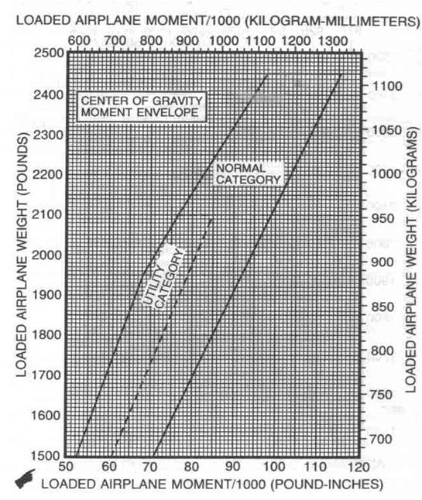
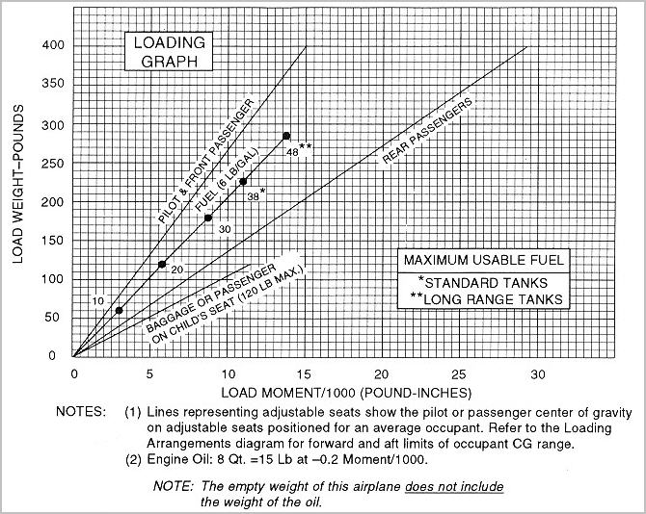
Inspection Requirements/ Acronyms

- F50AV1ATE – Acronym for inspections required on civilian aircraft.
Fire Ext. Every 30 days
50 50 Hour (SkyWarrior policy)
Annual Every 12 Calendar months
VOR Every 30 Days (IFR)
I00 100 Hour (For all aircraft that operate for hire)
Altimeter (Pitot Static System) Every 24 Calendar months (IFR)
Transponder Every 24 Calendar months
ELT Every 12 Calendar months
- AAROW – Acronym for documents required aboard an airplane.
Airworthiness certificate
Registration for the aircraft
Radio Operator’s License (for International Flights)
Operating limitations (POH-Pilot’s Operating Handbook, Placards, Checklists)
Weight and Balance Data Sheet
- LAHSO – Acronym for airport procedures
Land
And
Hold
Short
Operations
- IMSAFE – Acronym for human factors and flight safety.
Illness
Medication
Stress
Alcohol
Fatigue
Eating
- PARE – Acronym for proper spin recovery
Power Idle
Ailerons neutral
Rudder opposite
Elevator down

- CFIT – Acronym for loss of situational awareness
Controlled
Flight
Into
Terrain
- ABCD – Acronym for engine loss in flight
Airspeed
Best place to land
Checklist
Ditching
- SAFETY – Acronym for passenger brief
Seat Belts
Air Vents
Fire
Egress
Talking/Traffic
Y Why? (questions)

IFS Standards
IFS maneuver standards
Listed below are the maximum deviations allowed to stay within the standards set forth for IFS students. These standards can also be found in the Jeppesen Syllabus.

Straight Level: Altitude: +150 Feet Hdg: +15 degrees of assigned heading
Turns: Altitude: +150 Feet Hdg: +15 degrees of assigned heading
Stalls: Altitude: +150 Feet Hdg: +15 degrees of assigned heading

Steep turns: Altitude: +150 Feet Hdg: rollout within 15 degrees of heading
Turns around
a point Altitude: +150 Feet Hdg rollout within 15 degrees of initial heading
S-turns: Altitude: +150 Feet Hdg: rollout within 15 degrees of initial heading
Sim Inst Altitude: +200 Feet Hdg: +20 degrees.

Note: Students can have no more than two below average scores on items covered in the check flight and ground oral board combined in order to pass overall (example: below average scores in airspace and S-turns would still allow the SNA/SNFO to pass the check flight unless safety of flight was compromised)

The Garcon Transition/Arrival

& Midway Area

General - The Garcon Transition/Arrival procedures were developed to facilitate and expedite air traffic from KPNS to the beach training area and return to KPNS.
Procedure - Issued by pilot request only. By requesting the procedure, you are consenting to knowledge of the procedure. You must switch from tower to approach or approach to tower as directed, or no later than Point G, whichever occurs first.
Point P - PKZ NDB or baseball field quad.
Point G - Garcon Point toll booth/plaza
Point M - Midway Antennas
Frequency – 126.85 unless assigned an alternate frequency.
The Garcon Transition
Request the Garcon Transition departure from clearance delivery prior to your flight.
Runways: ALL
- Runway 8 - After departure turn directly to Point G. Thence:
- Runway 17 - After departure turn left cross wind directly to Point G (must remain north of Point P.) Thence:
- Runway 26 - After departure join left hand traffic pattern (remain between southern end of runway 17/35 and Point P). Upon reaching the SE corner of the pattern proceed direct to Point G. Thence:
- Runway 35: - After departure turn directly to Point G. Thence:
Thence: Climb to 1000’MSL. At Point G, proceed direct to Point M. At Point M, the procedure is complete. You may commence vertical and horizontal navigation at your discretion.

The Garcon Transition:
Procedure – Request Garcon Transition from PNS approach, only runways 8 & 17 are used for the Garcon Transition, if runways 35 and 26 are in use you would request your inbound procedure without reference to the Garcon Transition.
The Garcon Transition begins at 1500'MSL at Point M. From Point M proceed direct to Point G. From Point G proceed to the vicinity of Point P then enter the pattern as directed by ATC. Do not begin descent to TPA until the vicinity of Point P (abeam shoreline).
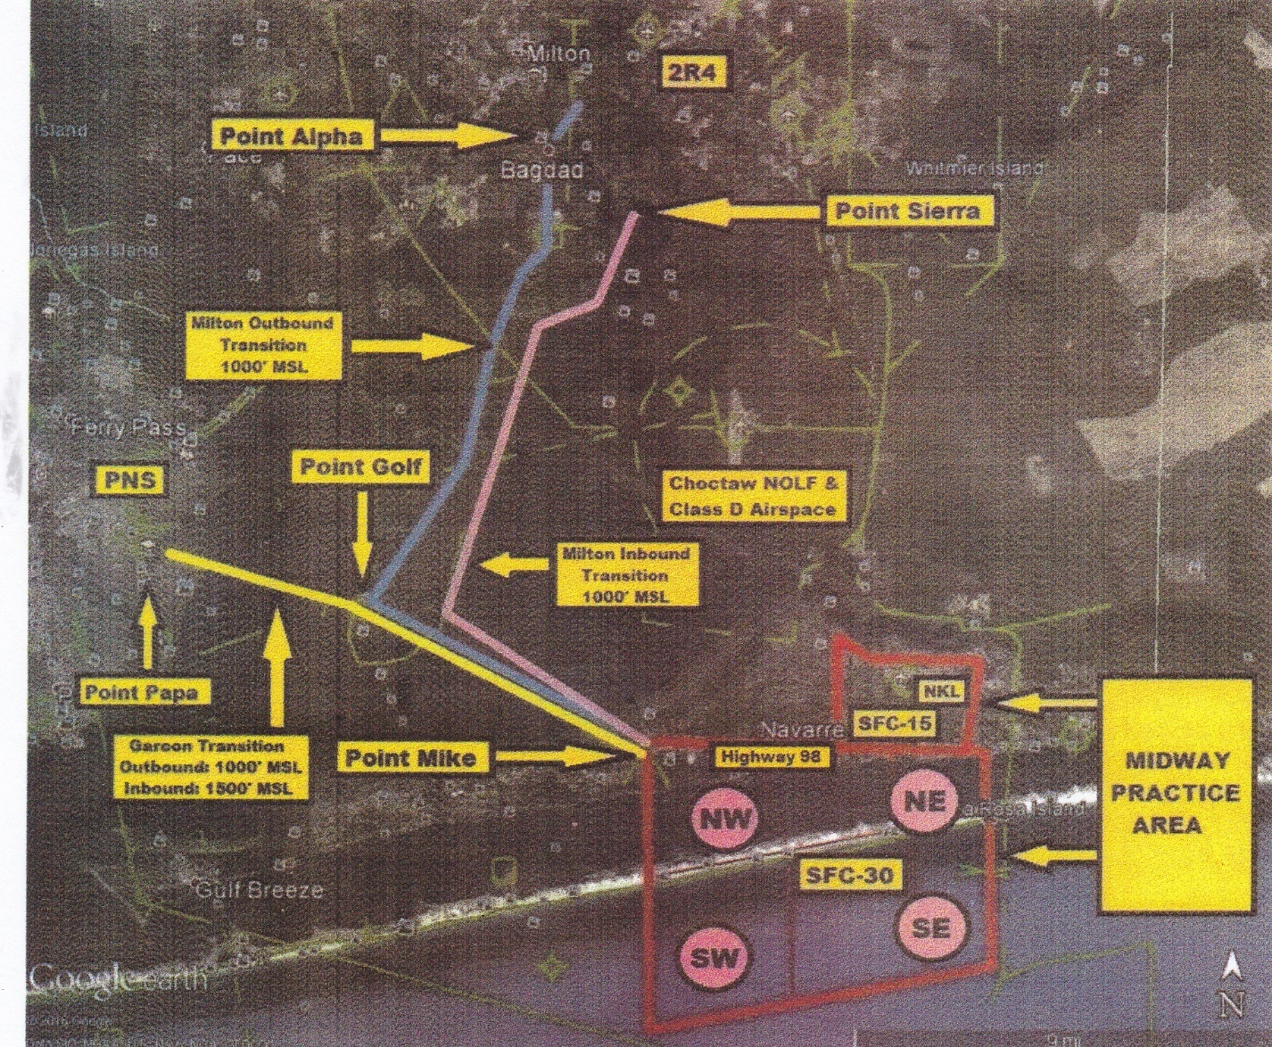

The North West Practice Area

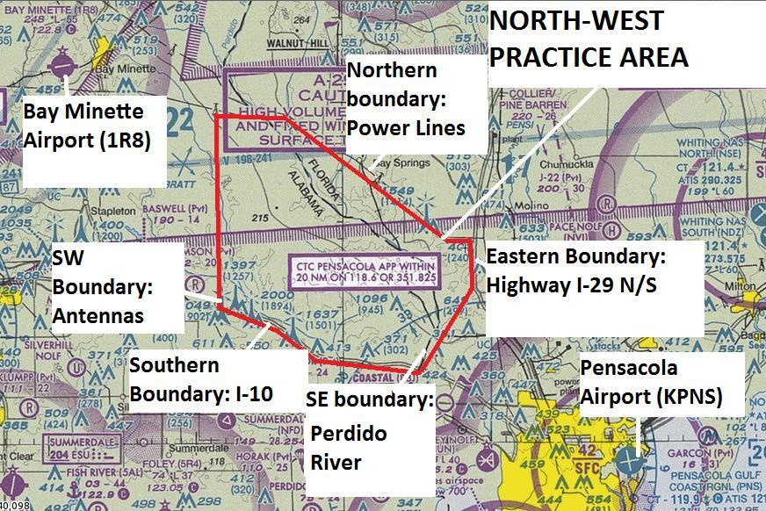

General – Unlike the Garcon Transition, clearance to the North-West practice area is not an assumed route of flight, altitude and frequency. Students must attain current ATIS information then call for clearance to the North-West practice area with a requested altitude. The clearance operator will then assign you a squawk code, initial altitude, departure frequency as well as acknowledge your requested altitude. Bay Minette airport is used by SkyWarrior as an alternate to KPNS.

FLIGHT LESSON 1
Total Schedule block: 2.0
Pre-Post brief time: 1.0
Flight time: 1.0
Landings: 2
Prior to your flight please be sure you have completed the following steps.
- Read over the SkyWarrior FTI.
- Print the 172 checklists off the SkyWarrior website.
- Print and complete the front page of the TOLD card. (page 54- 60)
- Print a current METAR and TAF off www.aviationweather.gov.
- Review flight lesson 1 in the Jeppesen Private Pilot Syllabus.
- Review Flight lesson 1 maneuvers in the Jeppesen Private Pilot Maneuvers Guide.
- Review the questions at the end of the Ground Operations section of the Private Pilot Maneuvers Guide.
- Review the questions at the end of the Basic Maneuvers section of the Private Pilot Maneuvers Guide.
- Review the questions at the end of the Airport Operations section of the Private Pilot Maneuvers Guide.
- Begin memorizing Pensacola Radio Frequencies listed on airport diagram.
- Begin memorizing the following 2 checklists: Takeoff and pre-landing/landing,
- Review the Garcon Transition arrival/departure for Pensacola International Airport.

* Flight one encompasses a lot of information so it is essential to be prepared. Radio frequencies and procedures as well as checklist are not expected to be memorized but will make flying the airplane a much smoother experience.

FLIGHT LESSON 2
Total Schedule block: 2.0
Pre-Post brief time: 1.0
Flight time: 1.0
Landings: 2
Prior to your flight please be sure you have completed the following steps.
- Read over the SkyWarrior FTI.
- Print the 172 checklists off the SkyWarrior website (if you did not save your copy).
- Print and complete the front page of the TOLD card (if you did not save your copy).
- Print a current METAR and TAF off www.aviationweather.gov.
- Review flight lesson 2 in the Jeppesen Private Pilot Syllabus.
- Review Flight lesson 2 maneuvers in the Jeppesen Private Pilot Maneuvers Guide.
- Review the questions at the end of the Ground Operations section of the Private Pilot Maneuvers Guide.
- Review the questions at the end of the Basic Maneuvers section of the Private Pilot Maneuvers Guide.
- Review the questions at the end of the Airport Operations section of the Private Pilot Maneuvers Guide.
- Continue memorizing Pensacola airport radio frequencies listed on airport diagram.
- Continue memorizing the following 2 checklist: Takeoff and pre-landing/landing
- Review the Garcon Transition arrival/departure for Pensacola International Airport.
- Review radio procedures for attaining clearance.

* Flight 2 is a review of flight one. If students are able to perform well it is a great opportunity to get some basic pattern work and landings.

FLIGHT LESSON 3
Total Schedule block: 2.0
Pre-Post brief time: 1.0
Flight time: 1.0
Landings: 2
Prior to your flight please be sure you have completed the following steps.
- Read over the SkyWarrior FTI.
- Print the 172 checklists off the SkyWarrior website (if you did not save your copy).
- Print and complete the front page of the TOLD card (if you did not save your copy).
- Print a current METAR and TAF off www.aviationweather.gov.
- Review flight lesson 3 in the Jeppesen Private Pilot Syllabus.
- Review Flight lesson 3 maneuvers in the Jeppesen Private Pilot Maneuvers Guide.
- Review the questions at the end of the Flight Maneuvers section of the Private Pilot Maneuvers Guide.
- Review the questions at the end of the Basic Maneuvers section of the Private Pilot Maneuvers Guide.
- Continue memorizing Pensacola airport radio frequencies listed on airport diagram.
- Continue memorizing the following 4 checklists: Takeoff, pre-landing/landing, power loss in flight and engine fails to restart.
- Review the Garcon Transition arrival/departure for Pensacola International Airport.
- Review the radio procedures for attaining ATIS, clearance and taxi.

* For flight 3 be sure to review stalls and slow flight.

FLIGHT LESSON 4
Total Schedule block: 2.5
Pre-Post brief time: 1.0
Flight time: 1.5
Landings: 5
Prior to your flight please be sure you have completed the following steps.
- Read over the SkyWarrior FTI.
- Print the 172 checklists off the SkyWarrior website (if you did not save your copy).
- Print and complete the front page of the TOLD card (if you did not save your copy).
- Print a current METAR and TAF off www.aviationweather.gov.
- Review flight lesson 4 in the Jeppesen Private Pilot Syllabus.
- Review Flight lesson 4 maneuvers in the Jeppesen Private Pilot Maneuvers Guide and UA (pg. 53)
- Review the questions at the end of the Emergency Landing Procedures section of the Private Pilot Maneuvers Guide.
- Review the questions at the end of the Ground Reference section of the Private Pilot Maneuvers Guide.
- Continue memorizing Pensacola airport radio frequencies listed on airport diagram.
- Continue memorizing the following 4 checklist: Takeoff, pre-landing/landing, power loss in flight and engine fails to restart.
- Review the Garcon Transition arrival/departure for Pensacola International Airport.
- Review all radio procedures.

* Flight lesson 4 introduces unusual attitudes which are not listed in flight lesson 4 of the Jeppesen Private Pilot Syllabus. Cross reference the SkyWarrior FTI as well as the Special Flight Operations section of the Jeppesen Private Pilot Maneuvers Guide. Review steep turns and
simulated emergency approaches.

FLIGHT LESSON 5
Total Schedule block: 2.5
Pre-Post brief time: 1.0
Flight time: 1.5
Landings: 5
Prior to your flight please be sure you have completed the following steps.
- Read over the SkyWarrior FTI.
- Print the 172 checklists off the SkyWarrior website (if you did not save your copy).
- Print and complete the front page of the TOLD card (if you did not save your copy).
- Print a current METAR and TAF off www.aviationweather.gov.
- Review flight lesson 5 in the Jeppesen Private Pilot Syllabus.
- Review Flight lesson 5 maneuvers in the Jeppesen Private Pilot Maneuvers Guide.
- Review the questions at the end of the Flight Maneuvers section of the Private Pilot Maneuvers Guide.
- Review the questions at the end of the Ground reference maneuvers section of the Private Pilot Maneuvers Guide.
- Continue memorizing Pensacola airport radio frequencies listed on airport diagram.
- Continue memorizing the following 4 checklist: Takeoff, pre-landing/landing, power loss in flight and engine fails to restart.
- Review the Garcon Transition arrival/departure for Pensacola International Airport.
- Review all radio procedures.

* Although the Jeppesen Private Pilot Syllabus shows the introduction of Slow Flight (IR) you are not required to perform this maneuver. Review ground reference maneuvers.

FLIGHT LESSON 6
Total Schedule block: 2.5
Pre-Post brief time: 1.0
Flight time: 1.5
Landings: 5
Prior to your flight please be sure you have completed the following steps.
- Read over the SkyWarrior FTI.
- Print the 172 checklists off the SkyWarrior website (if you did not save your copy).
- Print and complete the front page of the TOLD card (if you did not save your copy).
- Print a current METAR and TAF off www.aviationweather.gov.
- Review flight lesson 6 in the Jeppesen Private Pilot Syllabus.
- Review Flight lesson 6 maneuvers in the Jeppesen Private Pilot Maneuvers Guide.
- Review the questions at the end of the Airport Operations section of the Private Pilot Maneuvers Guide.
- Continue memorizing Pensacola airport radio frequencies listed on airport diagram.
- Continue memorizing the following 4 checklists: Takeoff, pre-landing/landing, power loss in flight and engine fails to restart.
- Review the Garcon Transition arrival/departure for Pensacola International Airport.
- Review all radio procedures.

*Review forward slips and go-arounds.

FLIGHT LESSON 7
Total Schedule block: 2.5
Pre-Post brief time: 1.0
Flight time: 1.5
Landings: 5
Prior to your flight please be sure you have completed the following steps.
- Read over the SkyWarrior FTI.
- Print the 172 checklists off the SkyWarrior website (if you did not save your copy).
- Print and complete the front page of the TOLD card (if you did not save your copy).
- Print a current METAR and TAF off www.aviationweather.gov.
- Review flight lesson 7 in the Jeppesen Private Pilot Syllabus.
- Review Flight lesson 7 maneuvers in the Jeppesen Private Pilot Maneuvers Guide.
- Review all maneuvers and procedures in the Jeppesen Private Pilot Maneuvers Guide.
- Continue memorizing Pensacola airport radio frequencies listed on airport diagram.
- Continue memorizing the following 4 checklists: Takeoff, pre-landing/landing, power loss in flight and engine fails to restart.
- Review the Garcon Transition arrival/departure for Pensacola International Airport.
- Review all radio procedures.

* Flight 7 is a review lesson. Be sure to review all maneuvers.

FLIGHT LESSON 8A
Total Schedule block: 2.5
Pre-Post brief time: 1.0
Flight time: 1.5
Landings: 5
Prior to your flight please be sure you have completed the following steps.
- Read over the SkyWarrior FTI.
- Print the 172 checklists off the SkyWarrior website (if you did not save your copy).
- Print and complete the front page of the TOLD card (if you did not save your copy).
- Print a current METAR and TAF off www.aviationweather.gov.
- Review flight lesson 8 in the Jeppesen Private Pilot Syllabus.
- Review Flight lesson 8 maneuvers in the Jeppesen Private Pilot Maneuvers Guide.
- Review all maneuvers and procedures in the Jeppesen Private Pilot Maneuvers Guide.
- Continue memorizing Pensacola airport radio frequencies listed on airport diagram.
- Continue memorizing the following 4 checklists: Takeoff, pre-landing/landing, power loss in flight and engine fails to restart.
- Review the Garcon Transition arrival/departure for Pensacola International Airport.
- Review all radio procedures.

* Flight 8A is a mock stage check. Be sure to review all maneuvers you have done to this point. Also your pre solo written exam is due to be graded.

FLIGHT LESSON 8B
Total Schedule block: 2.0
Pre-Post brief time: 1.0
Flight time: 1.0
Landings: As Required
Prior to your flight please be sure you have completed the following steps.
- Read over the SkyWarrior FTI.
- Print the 172 checklists off the SkyWarrior website (if you did not save your copy).
- Print and complete the front page of the TOLD card (if you did not save your copy).
- Print a current METAR and TAF off www.aviationweather.gov.
- Review the Performance Take Off and Landings section of the Jeppesen Private Pilot Maneuvers Guide.
- Continue memorizing Pensacola airport radio frequencies listed on airport diagram.
- Continue memorizing the following 4 checklists: Takeoff, pre-landing/landing, power loss in flight and engine fails to restart.
- Review all radio procedures.

* Flight 8B is a cleanup of anything you may have struggled with on your flight 8A. Generally speaking, you will spend most of your time practicing your landings.

FLIGHT LESSON 10
Total Schedule block: 2.5
Pre-Post brief time: 1.0
Flight time: 1.3
Landings: As Required
Prior to your flight please be sure you have completed the following steps.
- Read over the SkyWarrior FTI.
- Print the 172 checklists off the SkyWarrior website (if you did not save your copy).
- Print and complete the front page of the TOLD card (if you did not save your copy).
- Print a current METAR and TAF off www.aviationweather.gov.
- Review flight lesson 3 in the Jeppesen Private Pilot Syllabus.
- Review Flight lesson 3 maneuvers in the Jeppesen Private Pilot Maneuvers Guide.
- Review the questions at the end of the Flight Maneuvers section of the Private Pilot Maneuvers Guide.
- Review the questions at the end of the Basic Maneuvers section of the Private Pilot Maneuvers Guide.
- Continue memorizing Pensacola airport radio frequencies listed on airport diagram.
- Continue memorizing the following 4 checklists: Takeoff, pre-landing/landing, power loss in flight and engine fails to restart.
- Review the Garcon Transition arrival/departure for Pensacola International Airport.
- Review the radio procedures for attaining ATIS and clearance.

* Flight 10 is your Stage Check flight. The oral exam will take place prior to the flight so be sure to know the answers to the Oral Exam Review questions in the SkyWarrior FTI. Also be familiar with all memorized checklist and departure procedures.

FLIGHT LESSON 9
Total Schedule block: 2.0
Pre-Post brief time: 1.0
Flight time: 1.0
Landings: 3 with Instructor 3 Solo
Prior to your flight please be sure you have completed the following steps.
- Review the SkyWarrior FTI.
- Print the 172 checklists off the SkyWarrior website (if you did not save your copy).
- Print and complete the front page of the TOLD card (if you did not save your copy).
- Print a current METAR and TAF off www.aviationweather.gov.
- Review flight lesson 9 in the Jeppesen Private Pilot Syllabus.
- Review the Performance Take Off and Landings section of the Jeppesen Private Pilot Maneuvers Guide.
- Continue memorizing Pensacola airport radio frequencies listed on airport diagram.
- Continue memorizing the following 4 checklists: Takeoff, pre-landing/landing, power loss in flight and engine fails to restart.
- Review the airport diagram for KPNS as well as the lost communication procedures.
- Review all radio procedures.

* Solo flight, be sure to read up on your emergency procedures and pattern work.

Normal Takeoff and Climb

Clear for Traffic!
- Before takeoff check and takeoff brief – Complete
- Takeoff Clearance – As required
- Taxi into position while aligning nose wheel with centerline
- Heels on floor and feet off the brakes.
- Yoke slightly AFT of neutral to reduce weight on nose
- Full power (advance smoothly within 3 seconds)
- Rudder to maintain centerline and control yaw
- Allow aircraft to accelerate to Vr
- Rotate gently and allow the plane to lift off in ground effect
- Do not force the plane to lift off – let it lift off on its own
- Accelerate to Vy
- Maintain pitch attitude for Vy to desired altitude
- Trim as needed
Be sure to apply right rudder when applying power and in climb to offset P-factor

Crosswind Takeoff and Climb

Clear for Traffic!
- Before takeoff check and takeoff brief – Complete
- Takeoff clearance – As required
- Apply wind correction while taxing onto runway and lining up on runway centerline
- Heels on floor and feet off the brakes
- Aileron – Full into the wind
- Full power (advance smoothly within 3sec)
- Decrease aileron input as airspeed increases
- Rudder – As required to maintain directional control
- Vr plus 5MPH for better aircraft control
- After liftoff, then establish crab angle to track runway centerline
- Climb speed Vy
Be sure to apply right rudder when applying power and in climb to offset P-factor

Level Off (from climb or decent)
Pitch, Power, Trim!
- Adjust pitch to level (horizon approx. four fingers above the dash)
- Add or reduce power as necessary to a cruise setting.
- Trim to relieve control pressure.

Aborted Takeoff
When aborting a takeoff (either the student or the instructor has called “ABORT ABORT ABORT”):
- Power to Idle
- Maintain directional control with rudder and crosswind controls as needed
- Apply braking as necessary

Normal Approach and Landing
Pattern Altitude: 1000’ AGL Airspeed: 100 MPH
Entry: From traffic pattern
- Before landing check – Complete
- Carb heat - On
- Power – 1500 RPM
- Flaps (when airspeed permits) – As desired see notes below
- Glide path – Maintain with pitch for airspeed & power for altitude/glide path
- Round out / Flare – As required
- Touchdown on the main gear, slightly nose high, airspeed Vso + 5
- Roll-out – hold nose up with back elevator pressure, maintain centerline
Don’t Forget to Clear!
Flaps and Airspeed:
10° abeam the 1000’ markers and 90 mph
20°Base and 80 mph
30° Final and 70 mph
Bank angle NTE 30°, do not deploy flaps in turns

Crosswind Approach and Landing

Pattern Altitude: 1000’ AGL Airspeed: 100 MPH

- Wind correction angle – Apply as applicable
- Sideslip – Establish on final prior to rounding out (Aileron into wind and opposite Rudder), power as required
- Track to runway – Maintain center alignment
- Ailerons are for side drift and Rudder is for nose alignment with runway centerline
- Flare – As required, maintain slip attitude (Touchdown upwind main gear first, then downwind main, then nose gear), do not drop the nose!!!
- Gradually increase aileron into wind as airspeed decreases
- Touchdown – Nose high, airspeed Vso + 5 plus wind adjustment (1/2 gust factor)
- Roll-out – Aileron into wind; use rudder to track runway centerline

Don’t Forget to Clear!
Flaps and Airspeed:
10° abeam the numbers and 90 mph
20°Base and 80 mph
30° Final and 70 mph
Bank angle NTE 30°, do not deploy flaps in turns
Stronger winds/gusts may require use of higher airspeed and/or less flaps.

Go-Around/Rejected Landing
Don’t Forget to Clear!
Altitude: TPA 1000’ AGL Airspeed: Vx or Vy
Entry: From final approach
- Approach – Decision to abort or go around (make as early as possible during approach)
- Once committed to a go-around, do not change your mind
- Full throttle, Carb heat off, and Pitch up to Vy (nose on horizon)
- Retract flaps incrementally and allow the airplane to accelerate; do not sink
- Establish Vx (with obstacles) or Vy (without obstacles) as required (if establishing Vx, establish Vy after clear of obstacles)
- Maneuver – As necessary if traffic is a factor

Emergency Approach and Landing

- Aircraft control stabilized and establish best glide airspeed and trim
- Suitable landing field – Select and turn toward, note wind direction, set up to land into the wind. Maneuver to downwind 1000’ abeam the touchdown point if altitude permits.
- Check emergency immediate action items (These are memory items):
  - Fuel Selector to BOTH
  - Mixture FULL RICH – As Required
  - Throttle FULL (SIMULATE)
  - Carb Heat ON
  - Mags BOTH (or START if prop isn’t wind milling)
  - Master ON
  - Ignition ON
  - Primer IN/LOCKED
- Engine restart – If prop not turning
- If engine restarts land at nearest suitable airfield
IF ENGINE FAILS TO RESTART:
- Perform Securing checklist (simulate unless this is an actual emergency):
  - Fuel Selector to OFF
  - Mixture IDLE/ CUT OFF
  - Mags OFF
  - Master ON
- Squawk 7700 on transponder, or stay on current code if one was assigned. Declare emergency on 121.5 or local frequency (see note below)
- Landing approach – Establish
- Emergency landing check – Complete (time permitting – review checklist)
- Flaps as required
- Master off after extending full flaps
- Touchdown (simulated) – Initiate go-around by 500’ AGL
- Touchdown (actual) – Nose slightly high, airspeed Vso + 5
- Brakes - Apply Heavily
Don’t Forget to Clear!
“Mayday, Mayday, Mayday, Cessna 7106G is engine out 6 miles north of Bay Minette Airport off-field landing, two souls on board”

TRAFFIC PATTERN
Assuming #1 for the runway
TURN CROSSWIND AT 400’ AGL
Vy CLIMB

8

TRAFFIC PATTERN ALTITUDE
1000’ AGL
APPROX ½ MILE

POWER REDUCTION WITH INTERVAL:
1500’ MARKERS
FLAPS 10 DEGREES,
90 MPH / 85 KTS (if #2, this occurs abeam #1)
TAKEOFF:
FULL POWER
“GAUGE GREEN, AIRSPEED ALIVE”
26

FINAL:
FLAPS 30 DEGREES
70 MPH / 65 KTS
BASE:
FLAPS 20 DEGREES
80 MPH / 75 KTS
500-700’ AGL
TURN BASE:
WHEN 45 DEGREES
FROM END OF RUNWAY
*Do not lower flaps while turning!

Forward Slip

To steepen the airplanes descent angle and increase altitude loss without changing track or airspeed:
- Power - Idle
- Aileron - into wind or as desired
- Opposite rudder – Full
- Adjust ailerons as necessary to maintain ground track
- Airspeed – Maintain with pitch
- Recover when back on glide path, prior to round-out
CAUTION: Check pilot’s operating handbook for limitations before attempting this maneuver.
NOTE: Airspeed indicator may be unreliable during a slip.
Don’t Forget to Clear!

Side Slip

To compensate for wind drift during crosswind landings and maintain centerline
- Rudder – As required to maintain alignment with runway centerline
- Aileron into wind – As required, opposite direction of drift
- Airspeed and descent – Maintain with pitch for airspeed and power for altitude/glide path
- Constant control adjustments may be required due to changes in wind direction and velocity
- Maintain Side Slip during round-out, flare, and touchdown
- Increase aileron crosswind correction during rollout / ground roll.
- See Crosswind Approach and Landing
CAUTION: Check pilot’s operating handbook for crosswind limitations
Don’t Forget to Clear!

Slow Flight Dirty (Flaps)

Pre-maneuver checklist: Fuel on both, Mixture rich, Landing light on, clearing turns (two 90° turns in both directions or one 180° turn)
Entry:
- Carb heat - ON
- Power – Reduce (1500 RPM)
- Pitch and Trim – As required to maintain altitude
- Flaps (as speed permits) – Extend to full (anticipate the nose up tendency and add slight forward pressure on the elevator
- Airspeed Vso + 5 – Maintain altitude using approximately 2000 RPM. Use pitch for airspeed and power for altitude - It may take a combination of both.
- Increase Right Rudder as additional power is applied.
- Pitch and trim to maintain air speed and altitude
- Turns – Increase RPM by approximately 100 RPM when banking & reduce power as you return to level flight
Recovery:
- Power – Maximum /Carb heat off
- Pitch – As required to maintain altitude – Look outside! (If not under Foggles)
- Flaps – Retract to 0° in increments of 10°
- Maintain heading and altitude
Don’t Forget to Clear! Use shallow banks at standard rate. Bank angle not to exceed 20 °!

Slow Flight Clean (No Flaps)

Pre-maneuver checklist: Fuel on both, Mixture rich, clearing turns (two 90° turns in both directions or one 180° turn)
Entry:

- Carb heat - ON
- Power – Reduce (1500 RPM)
- Pitch – As required to maintain altitude
- Airspeed Vs + 5 – Maintain (approximately 1700-1800 RPM). Use pitch for airspeed and power for altitude - It may take a combination of both.
- Trim
- Turns – Add approximately 100 RPM when banking & reduce when you return to level flight
Recovery:
- Power – Maximum / Carb heat off
- Pitch – As required to maintain altitude
- Trim
- Maintain heading and altitude
Don’t Forget to Clear!
Use shallow banked turns (Standard rate).
Bank angle not to exceed 20 degrees!

Power Off Stall
Simulated Approach to Landing Stall

Pre-maneuver checklist: Fuel on both, Mixture rich, clearing turns (two 90° turns in both directions or one 180° turn)
Entry:
- Note Heading and pick an outside reference point
- Carb heat – On
- Power – 1500
- Flaps – Extend to 30° in increments
- Establish a stabilized descent at 70 mph/65 Kts
- Power – Idle
- Straight Ahead or Bank – As desired (NTE 20°)
- Smoothly increase pitch attitude to maintain altitude and induce stall (approx. 5-10° above horizon)
- Maintain coordinated flight (Ball centered - Turn Coordinator)
Recovery:
- Power – Maximum
- Carb Heat off
- Elevator – Relax (slight nose down)
KEEP NOSE STRAIGHT WITH RUDDER
DO NOT POWER DIVE, MINIMUM ALTITUDE LOSS
- Wings – Roll level (RUDDER!)
- Pitch – Positive rate of climb (LOOK OUTSIDE!)
- Wing flaps – Retract in increments
- Accelerate to Vx or Vy
- Establish climb – Maintain a Vx or Vy climb until told to level off
- Maintain heading
Don’t Forget to Clear!
As the airplane approaches a stall, the control feel is “mushy” or “soft”. As the airplane slows you will notice a decrease in engine sound as well as the tone and intensity of slipstream noise. The stall warning will usually sound 5 to 10 MPH above stall speed. You may notice buffeting and further loss of control effectiveness just before stall occurs.

Power On Stall
Simulated Departure Stall

Pre-maneuver checklist: Fuel on both, Mixture rich, clearing turns (two 90° turns in both directions or one 180° turn)
Entry:
- Note Heading and pick an outside reference point
- Carb heat – On
- Power – 1500
- Slow to Vr by steadily increasing pitch with trim, maintain altitude.
- Carb heat - Off
- Power – Full (anticipate the need for right rudder)
- Straight Ahead or Bank – As desired (NTE 20°)
- Smoothly increase pitch attitude to induce stall (approx. 20-25° above horizon)
- Maintain coordinated flight (Ball centered - Turn Coordinator)
Recovery:
- Elevator – Relax (Decrease angle of attack)
KEEP NOSE STRAIGHT WITH RUDDER
DO NOT POWER DIVE, MINIMUM ALTITUDE LOSS
- Wings – Roll level (Rudder)
- Pitch – Positive rate of climb – LOOK OUTSIDE!
- Accelerate to Vx
- Establish climb – Maintain a Vx climb until told to level off
- Maintain heading
Don’t Forget to Clear!
As the airplane approaches a stall, the control feel is “mushy” or “soft”. As the airplane slows you will notice a decrease in engine sound as well as the tone and intensity of slipstream noise. The stall warning will usually sound 5 to 10 MPH above stall speed. You may notice buffeting and further loss of control effectiveness just before stall occurs.

Steep Turns

Airspeed: 100 MPH
Pre-maneuver checklist: Fuel on both, Mixture rich, clearing turns (two 90° turns in both directions or one 180° turn)
Entry: Pick a visual reference outside and note heading
- Roll-in – 45° angle of bank, ±5°, maintain
- Add trim (approximately 2 smooth top to bottom rotations) and Power (50-150RPM) when rolling in
- Look outside for bank and pitch in relation to horizon – peek inside to verify altitude etc.
- Elevator pressure – As required to maintain altitude, trim as required (use small corrections)
- Maintain airspeed + or – 10 mph, altitude + or – 100’, rollout on original heading + or - 10° or visual reference point, reduce power and trim as required to maintain entry altitude and airspeed.
CAUTION: Check Pilot’s Operating Handbook for limitations
Don’t Forget to Clear!

Turns Around a Point

Altitude: 1000’ AGL Airspeed: 100 MPH
Pre-maneuver checklist: Fuel on both, Mixture rich, clearing turns (two 90° turns in both directions or one 180° turn)
Entry: Abeam point (downwind entry)
- Pick a point and enter downwind (no more than half way up the strut)
- Initial bank – Smoothly roll-in bank to steepest angle NTE 30°- 40°
- Downwind to crosswind – Decrease bank slowly (medium bank angle)
- Crosswind to upwind – Slowly decrease to shallowest bank angle
- Upwind to crosswind – Increase bank slowly (medium bank angle)
- Crosswind to downwind – Increase bank slowly to steepest bank angle
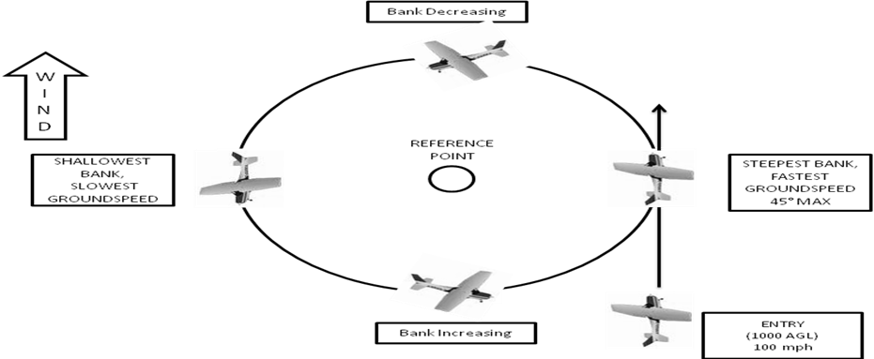
Don’t Forget to Clear! Maintain your reference around the point.

Rectangular Course

Traffic patterns may be used in lieu of this maneuver
Altitude: 1000’ AGL Airspeed: 100 MPH
Entry: downwind at 45° angle
- First track – Establish wind correction angle, if required
- Downwind to crosswind – Maximum bank 30°, more than 90° of turn
- Crosswind to downwind – Normal bank, less than 90° of turn
- Upwind to crosswind – Shallow bank, less than 90° of turn
- Crosswind to downwind – Increase to maximum bank, more than 90° of turn
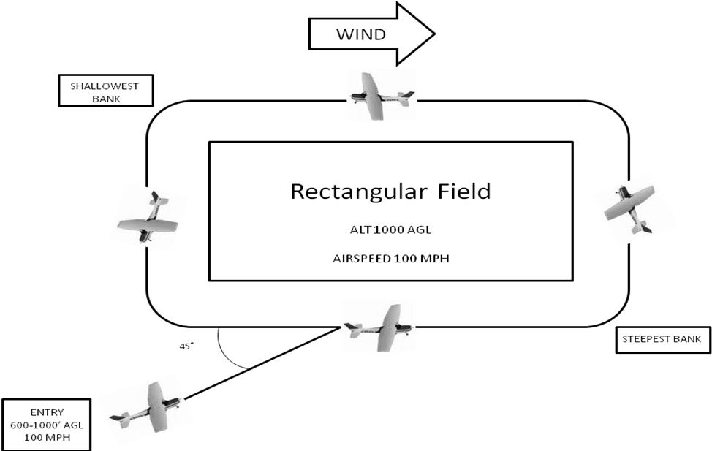
Don’t Forget to Clear!

S-Turns

Altitude: 1000’ AGL Airspeed: 100 MPH
Pre-maneuver checklist: Fuel on both, Mixture rich, clearing turns (two 90° turns in both directions or one 180° turn)
Entry: Downwind, reference line perpendicular to wind
- Pick a reference and enter downwind
- Initial bank – Smooth rate to steepest bank angle NTE 30°- 40°
- Downwind to crosswind – Decrease bank slowly to shallowest bank angle
- Crosswind to upwind – Decrease bank to wings level crossing reference line
- Upwind to crosswind – Increase bank slowly shallowest bank angle
- Crosswind to downwind – Increase bank slowly to steepest angle NTE 30°- 40°
- Roll-out – Wings level crossing reference line
Don’t Forget to Clear!

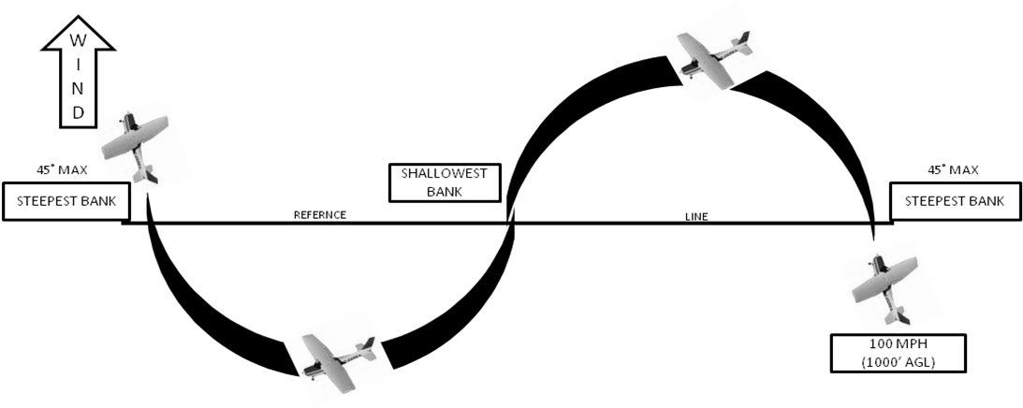

Unusual Attitude Recovery

Pre-maneuver checklist: Fuel on both, Mixture rich, clearing turns (two 90° turns in both directions or one 180° turn)
Nose-High Attitude:

- Simultaneously, lower the nose to place the miniature airplane on the horizon bar of the attitude indicator and add power full to prevent loss of airspeed
- Level wings
INDICATIONS: Nose high on attitude indicator, increasing altimeter, positive rate of climb, change of heading on heading indicator if aircraft is in a bank, and decreasing airspeed
Nose- Low Attitude:
- Simultaneously, reduce power idle and level wings
- Smoothly raise the nose to a level flight attitude without excessive back pressure
INDICATIONS: Nose low on attitude indicator, decreasing altimeter, high rate of decent on VSI, change of heading on heading indicator if aircraft is in a bank, increasing airspeed.

Radio Call Examples
As a pilot at SkyWarrior you will be required to obtain ATIS information, request a clearance, communicate with ground, tower and approach and departure.
Garcon Transition Departure Example Radio Call
For this example call, we are going to assume the following information.
- We are SkyWarrior 469
- Information “HOTEL” is the current ATIS

Student: “Pensacola clearance SkyWarrior 469 request Garcon Transition to the beach practice area with information HOTEL”.
Clearance: “SkyWarrior 469 maintain VFR on the Garcon Transition squawk 4334.”
Student: “Maintain VFR on the Garcon Transition squawk 4334, SkyWarrior 469.”
Clearance: “SkyWarrior 469 read back correct.”
North West practice area Example radio call:
For this example, we are going to assume the following information.
- We are in aircraft N-7087G
- Information “MIKE” is current.

Student: “Pensacola clearance Skyhawk 7087G request VFR to the North-West practice area at 2,500 feet with information HOTEL”.
Clearance: “Skyhawk 7087G maintain VFR at or below 1700 feet on departure contact 118.6 or 119.0 squawk 4221.
Student: “Maintain VFR at or below 1700 feet contact 118.6 or 119.0on departure, squawk 4221, SkyWarrior 469.”
Clearance: “Skyhawk 7087G read back correct.”

Example radio call for staying in the traffic pattern:
For this example, we are going to assume the following information.
- We are in aircraft N-84225
- Information “TANGO” is current.

Student: “Pensacola clearance Skyhawk 84225 request VFR closed traffic with information TANGO.”
Clearance: “Skyhawk 84225 maintain VFR closed traffic squawk 4343.”
Student: “Maintain VFR closed traffic squawk 4343, Skyhawk 84225.”
Clearance: “Skyhawk 84225 read back correct.”

Example radio call for taxing to the run up area:

For this example, we are going to assume the following information.
- We are in aircraft N-46601
- Information “LIMA” is current.
- The plane is running and the preflight checklist has been completed.

Student: “Pensacola ground Skyhawk 46601 at PAC taxi to run up area.”
Ground: “Skyhawk 46601 taxi to run up via Charlie Delta.”
Student: “Taxi to run up via Charlie Delta, Skyhawk 46601.”

Example radio call for taxing to the active runway:

For this example, we are going to assume the following information.
- We are in aircraft N-46601
- Information “LIMA” is current.
- The plane is running and run up checklist has been completed.
- Runway 17 is in use.

Student: “Pensacola ground Skyhawk 46601 at run up taxi to runway 17.”
Ground: “Skyhawk 46601 taxi to 17 via Charlie cross runway 26.”
Student: “Taxi to 17 via Charlie cross runway 26, Skyhawk 46601.”

Example radio call to Tower requesting takeoff:

For this example, we are going to assume the following information.
- We are in aircraft N-78650
- We are at the bravo intersection of runway 17 hold short line and all checklists have been completed.
- Runway 17 is in use.

Student: “Pensacola tower Skyhawk 78650 is holding short runway 17 at bravo ready for takeoff.”
Tower: “Skyhawk 78650, Pensacola tower runway 17 at bravo clear for takeoff fly runway heading.”
Student: “Runway 17 at bravo cleared for takeoff fly runway heading Skyhawk 78650.”

Example radio call to Pensacola Approach:

For this example, we are going to assume the following information.
- We are in aircraft N-78650
- We are currently flying in the Northwest practice area.
- Information “Mike” is current.

Student: “Pensacola approach Skyhawk 78650 is 20 miles northwest of the Pensacola airport at 2,500 feet with information “Mike” requesting full stop at Pensacola.”
Approach: “Skyhawk 78650, Pensacola approach, proceed inbound left base for runway 8.”
Student: “Proceed inbound left base for runway 8, Skyhawk 78650.”

Oral Exam Questions
1. What documents are required to be in the aircraft?
2. What documents are required to be in the pilot’s possession for flight?
3. What are the VFR required inspections for civil aircraft used in instruction?
4. What are the airworthiness requirements for both pilot and aircraft? (IMSAFE)
5. What equipment is lost with a total electrical failure in the aircraft and the indications?
6. What instruments are lost with a vacuum failure in the aircraft and the indications?
7. What instruments are on the pitot/static system?
8. What are the VFR fuel requirements for local flights?
9. What are the limitations for weight in this aircraft?
10. What are the definitions for the following V speeds; what are the specific speeds for this aircraft:
Vso_____ Vs1_______ Vx ______ Vy_______ Vfe______ Va______ _ Vno_______ Best Glide______
11. What are your weather sources? Both official and non-official?
12. What is the local airspace designation and its boundaries?
13. What is the VFR weather minimum for this airspace?
14. What are Class C, E and G airspace minima and requirements?
15. What are the weather minimums for controlled and uncontrolled airspace?
16. Airport markings for taxiway, hold short, runway, aiming blocks, ATC light signals?
17. Wake turbulence avoidance-visual and using PAPI
18. Emergency Immediate Action Items……
19. What is a low approach?
20. What is a runway incursion?
21. Know the Acronyms on pg. 12-13.

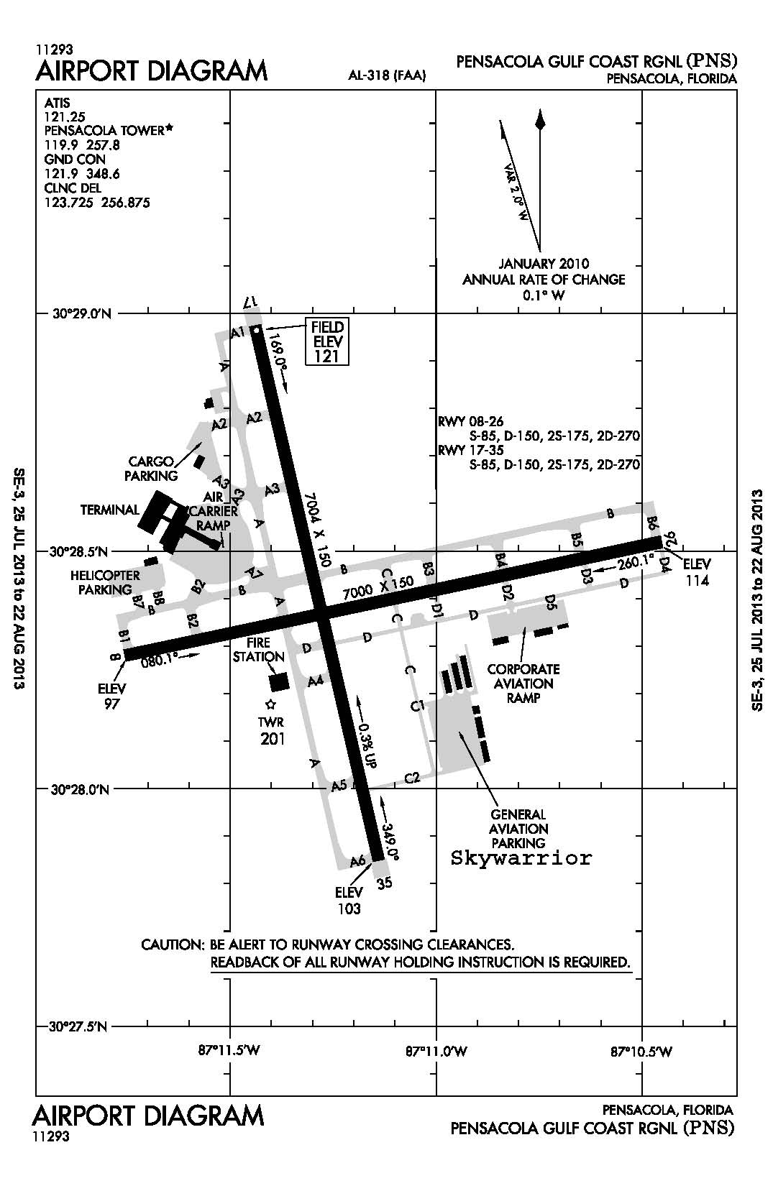

Tail Number _______ Date ___/___/___
Weight and Balance | Weight (lbs) | Arm (in) | Moment (lb. + in)
Basic Empty Weight
Pitot/Front Pax
Rear Seat
Baggage Weight
Start/Taxi/Run-up
Takeoff Weight/CG
Estimated Fuel Burn
Landing Weight/CG

Distances |  |  | Ground Roll |  |  |  | 50 ft. Obstacle
Takeoff
Landing
Airport |  |  |  |  | Available Runway
 | Vs  Vs₀  V_{R}  Vx | _____  _____  _____  _____ |  | Vy  V_{FE}  V_{NO}  V_{NE} |  | _____  _____  _____  _____
Va₁ _____
TOLD CARD INSTRUCTIONS
Weight & Balance Section
- Get BEW and moment from aircraft data page 8 -15 in FTI and divide aircraft moment by 1000.
- Add your weight plus 180 lbs. for the instructor.
- Add 180 lbs. if you have a backseat passenger.
- Assume full fuel – 38 gallons @ 6 lbs. per gallon
- Total all weights for ramp weight
- Subtract 6 lbs. (1 gallon) for aircraft engine start, taxi and run-up
- Total will be your takeoff weight
- Get estimated fuel burn from cruise performance table on pg. 6-4 of Cessna 172 manual. Use either 1 hour or 1.5 hours for flight time depending on current lesson.
- Subtract #8 from #7 to get landing weight
- Get moments from loading graph pg. 4-7 of Cessna 172 manual
- Total the moments (subtract start/taxi/run-up) to get takeoff moment.
- Subtract fuel burn moment from the takeoff moment to get landing moment. Use CG graph on pg. 4-8 in C-172 manual to determine if aircraft is within CG limits.
Distances Section
- For takeoff/landing distance use charts on pg. 6-3 and 6-5 of C-172 manual.
Airport Section
- For runway numbers and lengths use airport diagram on pg. 51 of FTI.

V-Speeds Section
- For V-Speeds data use pg. 4 on the IFS FTI.
Maneuvering speed Section
- For maneuvering speed use given formula, using landing weight from #9, divided by 2300, take the square root and multiply by 122mph or 97kts depending on aircraft.

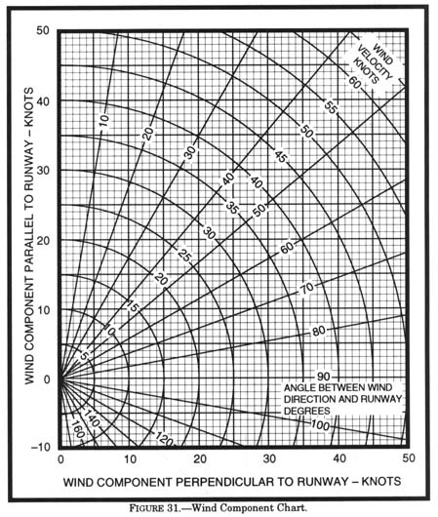

THIS PAGE LEFT BLANK INTENTIONALLY

