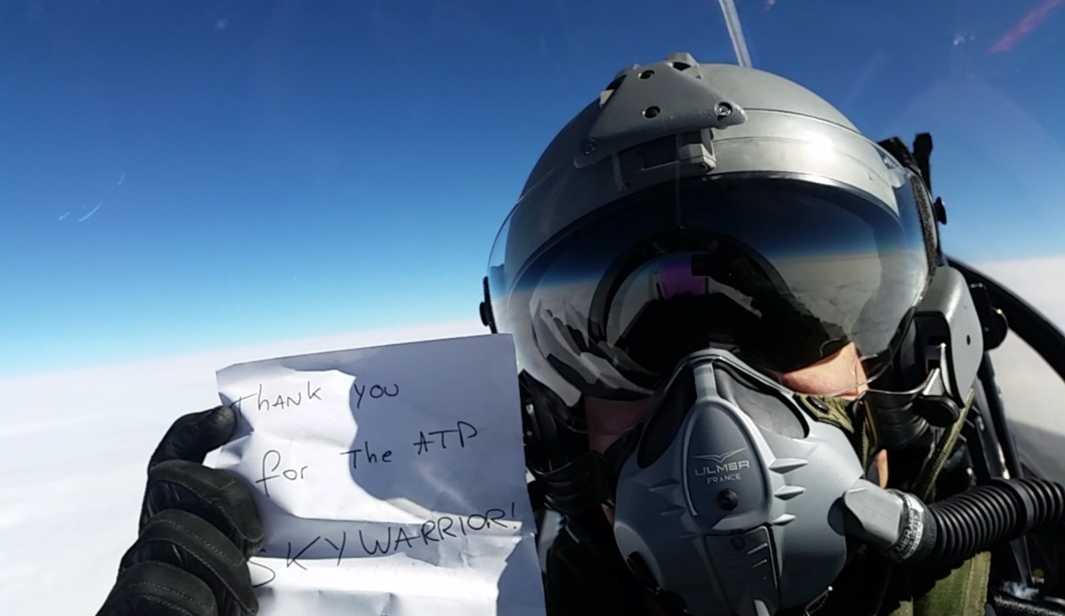

SkyWarrior Multi-Engine Guide

SkyWarrior Flight Training Inc.
4141 Maygarden Rd.
Pensacola, FL 32504

ATP / Multiengine Aircraft Introduction

The SkyWarrior Multiengine Aircraft Guide provides supplemental information to assist you in learning the unique qualities associated with flying a multiengine airplane. This Flight training manual has been developed to help ATP applicants train as efficiently as possible. The information contained within this manual will help you meet and exceed the required standards for successful completion of training for your ATP certificate.

Prerequisites for Training
To be eligible for this program you must:
- Hold a Current FAA Medical Certificate
- Be at Least 23 Years of Age, or 21 if applying based under the requirements of FAR 61.160
- Have Proof of FAA Eligibility based on one of the Following:
  - FAA Commercial Pilot Certificate with Instrument Airplane Multiengine Land Rating
  - Military experience per FAR 61.73
- Have Passed the ATP Knowledge Test after completion of an Airline Transport Pilot Certification Training Program specified in FAR 61.156.
- Be Instrument Current & Proficient. If not, you may require additional training to ensure proficiency.
- Have Documented Flight Time per FAR 61.159 Requirements:
  - 1,500 Hours Total Time:
    - 500 Hours Cross Country Time
    - 100 Hours Night Time
    - 75 Hours Instrument Time of Actual or Simulated Instrument Time:
      - 50 Hours must be in an Airplane
    - 250 Hours PIC Airplane, including 100 hours cross country time and 25 hours of night flying time
    - 50 Hours Airplane Multiengine Land
Refer to FAR 61.160 for aeronautical experience requirements for the airplane category restricted privileges based on either military flying experience or graduating with a bachelor’s degree with an aviation major from an institution of higher education that has been issued a letter of authorization under FAR 61.169.
Based on these prerequisites, please bring the following with you when you arrive for training:
- Valid U.S. Passport or U.S. birth certificate and government-issued photo I.D.
- FAA Airman Certificate
- U.S. Military Pilots Taking Check ride Based on Military Experience:
  - Documented Military experience
- FAA Medical Certificate
- ATP Knowledge Test Score Report (Unexpired original only, not a copy. Name must match airman certificate exactly.)
- All Logbooks
- Headset, View Limiting Device, Kneeboard. (For your convenience, SkyWarrior includes complimentary headsets with training; however you are encouraged to have your own set.)

This course consists of 5 hours of ground instruction and 6 hours of flight instruction prior to an end of course flight check lasting approximately two hours. Initially, you will spend approximately a half hour (in person or over the phone) with an instructor to explain the course, an overview of the check ride, and recommended study strategies.
The ground and flight training can be tailored to the applicant; the basic schedule that we follow is on pages 5 - 7. The practical test with a Designated Pilot Examiner is an evaluation of you as a single pilot under IFR conditions, so it is very important that you be instrument proficient prior to beginning this course. The ATP Practical Test Standards (PTS) will show what will be expected of you on your check ride. The ATP PTS can be purchased in hard copy at SkyWarrior or can be downloaded from the FAA website at http://www.FAA.gov/.
All flight training will be conducted in a Piper PA-44-180 Seminole twin engine aircraft.
To optimize your training time, it is recommended that you:
- Be familiar with NACO (formerly NOS) format approach charts.
- Review all the instrument approach procedures for KPNS (except the NDB 35) and KCEW, as well as approach procedures incorporating either course reversal or missed approach holding patterns at NUN, JKA, CEW, CQF, and 0R1
- Study the amplified procedures in sections 3 and 4 from the Seminole Information Manual
- Study the systems information in the Seminole Information Manual in sections 2 (Aircraft Systems), and 8 (Aircraft Handling, Servicing, and Maintenance) and become familiar with the ATP PTS ( Sections 1 and 2; Tasks and Procedures)
- Review the normal and emergency checklists, committing the bold items to memory (to be done as a flow, then verified with the checklist)
- Familiarize yourself with the basic operation of the Garmin GNS430W (see the supplement in the back of this guide and/or our website for useful links (http://www.skywarriorinc.com)
- Study the Single Engine Aerodynamics section of this guide to aid in your understanding of One Engine Inoperative (OEI) operations and procedures
The day of your practical test, you will need to budget the full day. After reviewing your paperwork (application, logbooks, etc.), the examiner will quiz you on three main areas: Aeronautical Decision Making (ADM), aircraft performance, and aircraft systems. You should also be well prepared to discuss the Special Emphasis Areas listed in the PTS.

The flight portion of the practical test will most probably consist of (exact profile will be determined based on runways and approaches in use the day of the Practical Test) the following tasks, most of which shall be flown using a view limiting device:
- Simulated Engine Failure on Takeoff (rejected takeoff)
- Instrument Takeoff (view limiting in place at or before climbing to 100 feet AGL)
- In-flight Engine Failure (above 3,000 feet AGL) with Full Feather, Secure, and Restart
- Steep Turns
- Approaches to stalls
  - Flaps up
  - Flaps 25 degrees
  - Flaps 40 degrees
- Unusual Attitude Recoveries
- V_{mc} demo *(if limited to centerline thrust)*
- Holding
- Two Precision Approaches (one with simulated single engine)
- Two Non-Precision Approaches (one with simulated single engine)
- Simulated Single Engine Missed Approach
- Circle to Land
- Rejected Landing
- Emergency Descent
- Simulated Engine Failure on Climb Out
- Normal Landing
- No Flap Landing
- Simulated Single Engine Landing
Also, one non-precision approach will include a course reversal procedure turn and one approach will be flown with reference to backup or “fail down” instrumentation or navigation display. Typically, DPEs require one approach to be flown without the situational awareness normally provided by the moving map display of the GPS, relying only on the course information provided by the HSI. The examiner can incorporate additional tasks at his or her discretion.

FLIGHT LESSONS

All flight lessons and the end of course check flight shall be scheduled for two hours. Beginning with flight lesson 2 all maneuvers, with the exception of the visual landing pattern, shall be conducted with instrument reference only.

Flight Lesson 1
Normal Procedures under Visual Reference and Instrument Reference

- Normal Takeoff VR
- Approach to Stalls IR
  - Flaps up / Gear up (clean cruise configuration)
  - Flaps 25° Gear down (takeoff or approach configuration)
  - Flaps 40° / Gear down (landing configuration)
- Steep Turns IR
- Emergency Descent IR
- Two-Engine Approach IR
- Traffic Patterns VR
- Two-Engine Landings VR
- Rejected Landing VR

Flight Lesson 2
Engine Failures and One Engine Inoperative Procedures, Instrument Approach Procedures

- Simulated Engine Failure on Takeoff Roll (rejected takeoff)
- Simulated Engine Failure During Climbout
- Approaches to Stalls
  - Flaps up / Gear up
  - Flaps 25° Gear down
  - Flaps 40° / Gear down
- Steep Turns
- Unusual Attitude Recoveries
- Actual Engine Feather/Secure/Restart (above 3,000 feet AGL)
- Vmc Demonstration, if required due to restriction to centerline thrust
- Single-Engine Approach
- Single-Engine Missed Approach
- Two-Engine Approach
- Simulated Single-Engine Landing

Flight Lesson 3
Continued Practice on Normal and One Engine Inoperative Maneuvering and Approaches

- Rejected Takeoff
- Engine Failure During Climb
- Approach to Stalls
  - Flaps up / Gear up
  - Flaps 25° Gear down
  - Flaps 40° / Gear down
- Steep Turns (45° ±5°)
- Engine Shutdown/Feather/Restart (above 3.000 feet AGL)
- Holding
- Two-Engine Approach – Non-precision with Procedure Turn
- Single-Engine Approach – Precision with Failure of Attitude Indicator
- Single-Engine Missed Approach
- No-Flap Landing

Flight Lesson 4
End of Course Check with Chief Instructor, Assistant Chief, or Designated Check Instructor

- Rejected Takeoff
- Instrument Takeoff
- Steep Turns
- Approach to Stalls
- Unusual Attitudes Recoveries
- Engine Failure In-flight/Feather/Secure/Restart (above 3,000 feet AGL)
- Vmc Demonstration
- Emergency Descent
- Two-engine Precision Approach and Missed Approach
- Single-engine Non-precision Approach
- Single-engine Missed Approach to Holding Fix
- Holding
- Two-engine Precision Approach with Loss of Attitude Indicator
- Rejected Landing
- Full Flap Landing
- Simulated Engine Failure during Climbout
- Simulated Single-engine Landing – no Flaps

Note: all maneuvers must be performed to the criteria established in the ATP PTS.

GROUND LESSONS

The first ground lesson should be completed before the first flight lesson. The other ground lessons may be completed before or after flights two and three, but must be completed prior to the end of course check flight.

Ground Lesson 1

- Begin IACRA application, complete and submit subsequent to the end of course check flight and issuance of graduation certificate
- Review of Single Engine Aerodynamics, V_{mc} and Critical Engine Determination, and V Speeds
- Checklists
- Maneuvers
- Instrument Approach Procedures
- Landing Pattern Procedures
- Garmin GNS430W familiarization and operation
- Pre-Flight Preparation and Aircraft Inspection
- Review of SkyWarrior Safety Handbook

Ground Lesson 2

- PA 44-180 Seminole Aircraft Systems
- Performance Charts
- Weight and Balance

Ground Lesson 3

- Aeronautical Decision Making (ADM)
- Airworthiness (Aircraft Logbook Review)
  - Required Documents
  - Required Equipment
  - Airworthiness Directives (ADs)
  - Inspections
    - 100 Hour
    - Annual
    - ELT
    - Altimeter
    - VOR
    - Transponder

ENGINE OUT AERODYNAMICS

When operating a twin‐engine airplane with One Engine Inoperative (OEI), the penalties for loss of an engine are twofold: performance and control. The most obvious problem related to airplane performance is the loss of power (50%). This loss reduces climb performance by 80 – 90% or more. The second problem affects aircraft control caused by the remaining thrust, which is now asymmetrical. Attention to both of these factors is crucial in maintaining safe OEI flight.

When an engine failure occurs in a multiengine aircraft, the resultant asymmetric thrust and drag will cause the following effects on the aircraft’s axes of rotation:
Pitch Down (Lateral Axis)
Loss of accelerated slipstream over the horizontal stabilizer causes it to produce less negative lift, causing the aircraft to pitch down. To compensate for the pitch down effect, additional back pressure is required.

Roll Toward the Failed Engine (Longitudinal Axis)

The wing produces less lift on the side of the failed engine due to the loss of accelerated slipstream. Reduced lift causes a roll toward the failed engine and requires additional aileron deflection into the operating engine.

Yaw Toward the Failed Engine (Vertical Axis)

Loss of thrust and increased drag from the windmilling propeller cause the aircraft to yaw toward the failed engine. This requires additional rudder pressure on the side of the operating engine. The concept of “Dead foot, dead engine” can be used in determining the inoperative engine.
Sideslip Versus Zero Sideslip
During flight with one engine inoperative, proper pilot technique is required to maximize aircraft performance. An important technique is to establish a Zero Sideslip Condition.

Sideslip Condition (Undesirable)
When an engine failure occurs, thrust from the operating engine yaws the aircraft. To maintain aircraft heading with the wings level, rudder must be applied toward the operating engine. This rudder force results in the sideslip condition by moving the nose of the aircraft in a direction resulting in the misalignment of the fuselage and the relative wind. This condition usually allows the pilot to maintain aircraft heading; however, it produces a high drag condition that significantly reduces aircraft performance.

Zero Sideslip Condition (Best Performance)
The solution to maintaining aircraft heading and reducing drag to improve performance is the Zero Sideslip Condition. When the aircraft is banked into the operating engine (usually 2˚-5˚), the bank angle produces a horizontal component of lift. The horizontal lift component aids in counteracting the turning moment of the operating engine, minimizing the rudder deflection required to align the longitudinal axis of the aircraft to the relative wind. In addition to banking into the operating engine, the appropriate amount of rudder required is indicated by the inclinometer ball being “split” towards the operating engine side. The Zero Sideslip Condition aligns the fuselage with the relative wind to minimize drag and must be flown for optimum aircraft performance.

To take full advantage of the airplane’s capabilities, performance, and safety, multiengine pilots must be well‐trained, knowledgeable, and proficient.

Engine Inoperative Climb Performance
Climb performance depends on the excess power needed to overcome drag. As mentioned previously, when a multiengine airplane loses an engine, the airplane loses 50% of its available power. This power loss results in a loss of approximately 80% of the aircraft’s excess power and climb performance. Drag is a major factor relative to the amount of excess power available. An increase in drag must be offset by additional power.

With an engine failure, this additional power is now subtracted from the excess power, making it unavailable to aid the aircraft in climb. When an engine is lost, the pilot must maximize thrust (full power) and minimize drag (flaps and gear up, prop feathered, etc.) in order to achieve optimum single-engine climb performance.

Approximate Drag Factors per the Piper Seminole POH expressed as a reduction in the rate of climb otherwise obtainable
- Flaps 25˚.................................. -240 FPM
- Flaps 40˚.................................. -275 FPM
- Wind-milling Prop..................... -200 FPM
- Gear Extended......................... -250 FPM

TURNING TENDENCIES

The turning tendencies that affect single engine airplanes (i.e. torque and P‐factor) also affect multiengine airplanes. Given that multiengine airplanes have more than one engine, and those engines are located off the longitudinal axis of the airplane, these effects become more noticeable, particularly when one engine becomes inoperative.

Twin‐engine airplanes where the propellers for each engine rotate in the same direction are called conventional twins. In an effort to mitigate the effects of torque and P‐factor during OEI operations, some aircraft manufacturers developed twin‐engine airplanes with counter-rotating propellers. The effects of torque and p‐factor with counter‐rotating propellers will cancel each other out, resulting in equal rudder pressure in the event of an engine failure, regardless of which engine may become inoperative.

Conventional Twin

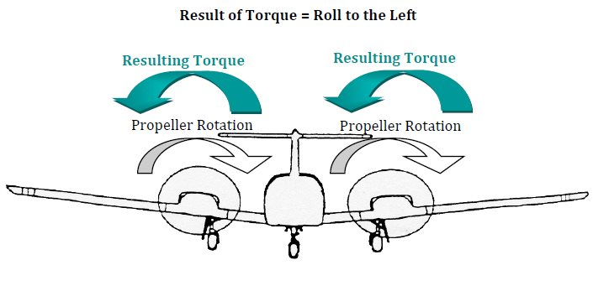

Conventional Twin

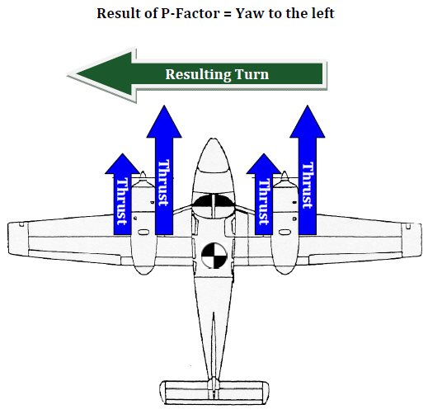

Counter-Rotating Propeller Equipped Aircraft

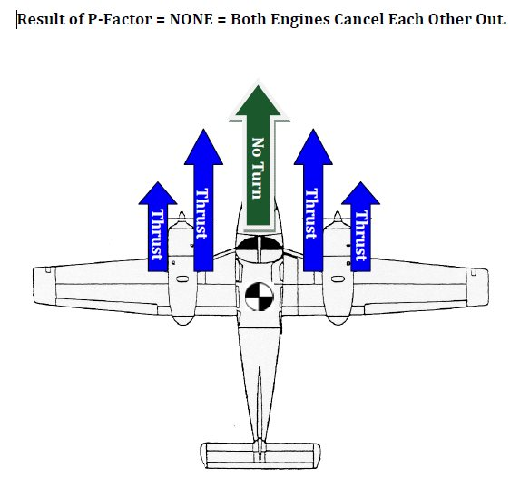

WHEN AN ENGINE FAILS
Two motions happen when an engine fails: YAW and ROLL.

- YAW‐ Asymmetrical thrust will cause a yawing moment around the C.G. towards the inoperative engine.

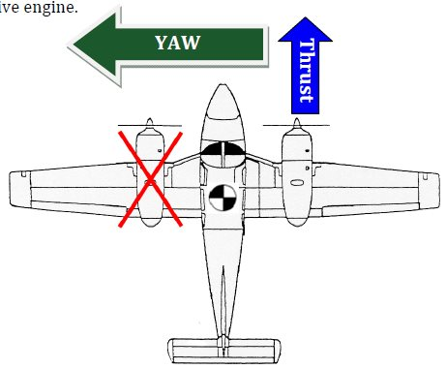

2. ROLL – The yawing moment from above will cause the wing with the operating engine to move faster through the air as the airplane yaws. This causes an increased velocity of air over the wing with the operative engine, meaning more lift on that wing, resulting in a roll towards the inoperative engine.

3. ROLL – Induced flow (accelerated slipstream) over the wing from the operating engine and lack of induced flow (accelerated slipstream) over the inoperative engine causes asymmetrical lift on the wings, resulting in a rolling moment around the C.G. towards the inoperative engine.

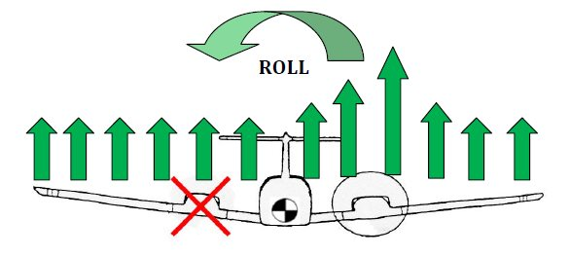

CRITICAL ENGINE
The critical engine is the engine that, if it were to fail, would most adversely affect the performance or handling characteristics of the airplane.

On conventional twins (with propellers rotating to the right) the critical engine is the left engine. On a twin engine airplane with counter-rotating propellers there is not a critical engine since the yawing and rolling effects of losing one engine will be identical no matter which engine fails.

There are four factors that determine if an engine is critical. A useful mnemonic device to remember is PAST.

1. P‐Factor
2. Accelerated Slipstream
3. Spiraling Slipstream
4. Torque

P-Factor (Yaw)
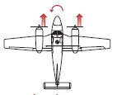
In conventional aircraft, both propellers turn clockwise as viewed from the cockpit. At low airspeeds and high angles of attack, the descending blade produces more thrust than the ascending blade due to its increased angle of attack. Though both propellers produce the same overall thrust, the descending blade on the right engine has a longer arm from the CG (or greater leverage) than the descending blade on the left engine. The left engine produces the thrust closest to center line. The yaw produced by the loss of the left engine will be greater than the yaw produced by the loss of the right engine, making the left engine critical.

Accelerated Slipstream (Roll and Pitch)
P-Factor causes more thrust to be produced on the right side of the propeller. This yields a center of lift that is closer to the aircraft's longitudinal axis on the left engine and further from the longitudinal axis on the right engine and also results in less negative lift on the tail.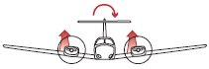 Because of this, the roll produced by the loss of the left engine will be greater than the roll produced by the loss of the right engine, making the left engine critical.

Spiraling Slipstream (Yaw)
A spiraling slipstream from the left engine hits the vertical stabilizer from the left, helping to counteract the yaw produced by the loss of the right engine. 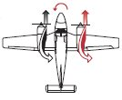However, with a left engine failure, slipstream from the right engine does not counteract the yaw toward the dead engine because it spirals away from the tail, making the left engine critical.

Torque (Roll)
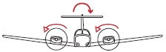For every action, there is an equal and opposite reaction. Since the propellers rotate clockwise, the aircraft will tend to roll counterclockwise. When the right engine is lost, the aircraft will roll to the right. The right rolling tendency, however, is reduced by the torque created by the left engine. When the left engine is lost, the aircraft will roll to the left, and the torque produced by the right engine will add to the left rolling tendency requiring more aileron input, which increases drag, making the left engine critical.

V_{MC} – 14 CFR Part 23.149
Every multiengine airplane must go through a certification process which includes calculating a V_{MC} speed. V_{MC} is NOT a fixed airspeed under all conditions. V_{MC} is a fixed airspeed only for the very specific set of circumstances under which it was determined during aircraft certification by 14 CFR Part 23.149.

§23.149 Minimum Control Speed
V_{MC} is the calibrated airspeed at which, when the critical engine is suddenly made inoperative it is possible to:
1. Maintain directional control of the airplane with that engine still inoperative,
2. Maintain straight flight at the same speed with an angle of bank of not more than 5 degrees.

V_{MC} must not exceed 1.2 V_{S1} at maximum takeoff weight.

V_{MC} must be derived using the following conditions (SMACFLUM):
1. Standard Day (15 degrees Celsius, Altimeter 29.92” at Sea Level)
2. Most unfavorable weight
3. Aft Center of Gravity (Most unfavorable center of gravity position)
4. Critical engine inoperative and the propeller in the recommended takeoff position
5. Flaps Retracted
6. Landing Gear Retracted, Trimmed for Takeoff
7. Up to 5° Angle of Bank into the operative engine
8. Maximum Power on the operative engine

NOTE
VMC deals only with directional control, not performance.

Remember, published V_{MC} and actual V_{MC} are two different speeds. There are many factors that can affect V_{MC} speed. The aircraft manufacturer determines V_{MC} using the above criteria.

RECOGNIZING AND RECOVERING AT V_{MC}

To recognize that VMC has been reached, or is about to be reached, there are four indications.

- Loss of directional control – the rudder pedal is depressed to its fullest travel and the airplane is still turning towards the inoperative engine.

- Stall warning horn – a single‐engine stall could be just as dangerous as running out of rudder authority and could even result in a spin.

- Aerodynamic buffeting before the stall – same reason as the stall warning horn.

- A rapid decay of control effectiveness – any further loss of control effectiveness could result in loss of control of the airplane.

To recover at V_{MC}, two actions must occur (simultaneously):

- Reduce power on the operating engine – this will reduce the asymmetrical thrust causing the loss of directional control.
- Pitch down – Lowering the nose of the airplane will increase the forward airspeed making the rudder more effective in regaining and maintaining directional control.

VMC vs. STALL SPEED

As density altitude increases, VMC speed decreases because as density altitude increases, engine power will decrease. The decrease in engine power results in less asymmetrical thrust, meaning the yawing from a failed engine will be less at a high density altitude than at a lower density altitude.

Stall speed is an indicated airspeed and will remain constant as altitude increases or decreases.

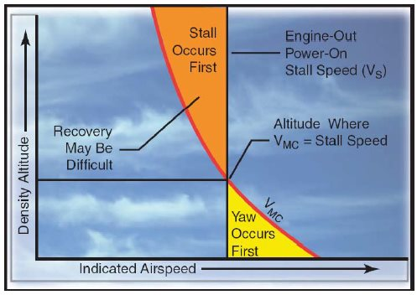

FACTORS AFFECTING V_{MC}

Published VMC will almost always be different than actual VMC. There are a lot of factors that can affect this speed, but there are a few important things to remember:

A decrease in V_{MC} is desirable because the airplane can fly slower before losing directional control.

Factors that cause V_{MC} to decrease:

Moving the C.G. forward will make the rudder more effective.
- Large arm to rudder = Larger rudder moment = Rudder more effective.
- Anything that will allow less rudder to be used, making more rudder available to the pilot.

An increase in V_{MC} is undesirable, because the airplane will lose directional control at a higher airspeed.

Factors that cause V_{MC} to increase:
Moving the C.G. aft will make the rudder less effective.
- Small arm to rudder = Smaller rudder moment = Rudder less effective.
- Anything that will cause more rudder to be used, making less rudder available to the pilot.

CENTER OF GRAVITY LOCATION

The C.G. location changes the length of the arm to the rudder: the longer the arm, the more effective the rudder; the more effective the rudder, the lower VMC. As the C.G. moves forward, VMC decreases; as the C.G. moves aft, VMC increases.
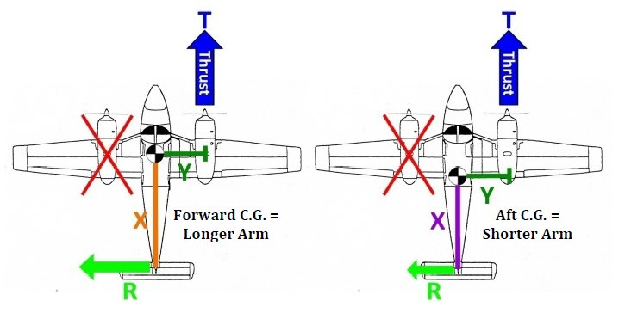

Performance increases as the C.G. is moved aft. As the C.G moves forward, more tail‐down force is needed to keep the airplane level. The more tail‐down force needed, the more total lift is required. When more lift is created (airplane flying at a higher angle of attack), more drag is also created. The increase in drag causes the overall speed to decrease.
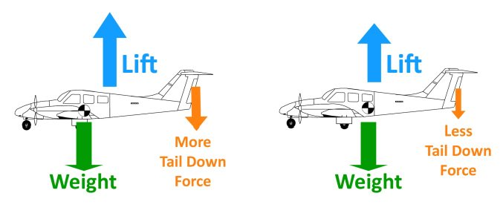

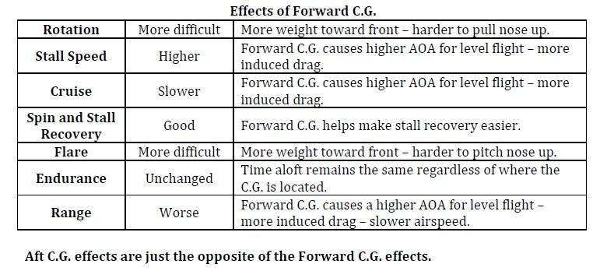

AVAILABLE POWER

The more power (thrust) produced by the operating engine, the more rudder deflection is needed to stop the resulting yaw. Using more rudder leaves less available to the pilot. Therefore, V_{mc} increases as power on the operating engine is increased.

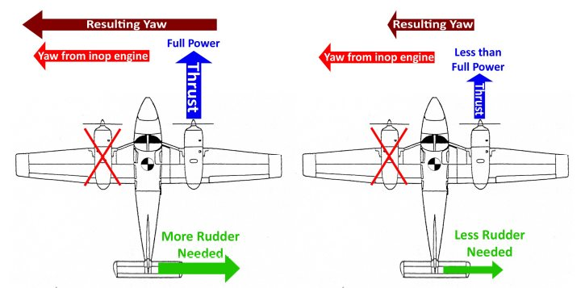

DENSITY ALTITUDE
As density altitude increases, temperature increases, pressure decreases, and/or humidity increases, the output of the engine or thrust created by the engine decreases. The less thrust that is created, the less rudder input is needed to oppose the yaw.

The need for less rudder deflection leaves more rudder authority available to the pilot. Therefore, V_{MC} decreases. So, as density altitude increases, temperature increases, pressure decreases, and/or humidity increases, V_{MC} decreases.

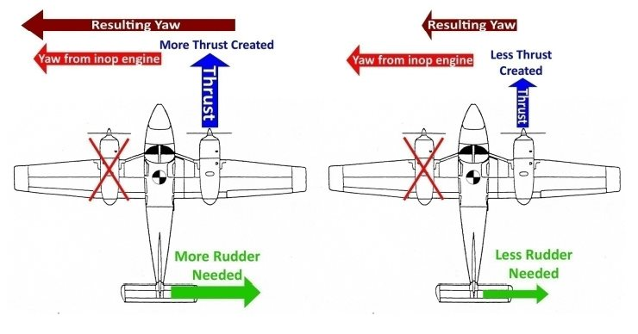

Performance decreases as density altitude increases, temperature increases, humidity increases, and/or pressure decreases. With air being less dense, not only does the engine become less efficient, but the propeller and wings also have decreased performance due to having less air molecules available to create thrust and lift.

GEAR POSITION
As the landing gear operates to retract or extend, the C.G. location moves in the direction of travel of the nose gear.

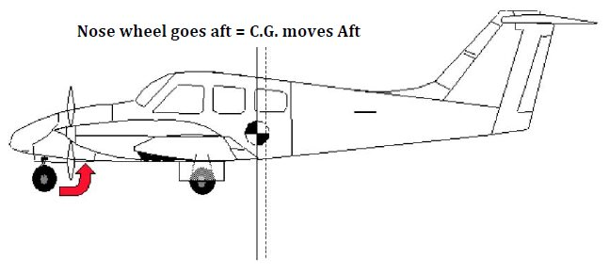
The change in C.G. can affect V_{MC} speed as stated previously. In the extended (down) position, the landing gear can also act like the keel of a boat, giving the airplane a stabilizing effect. This stabilizing effect helps prevent a yaw, thereby lowering V_{MC}.

NOTE
The current Piper Seminole POH/IM states: “fuel burn off and gear movement
do not significantly affect C.G. location (page 615).”

Extending the landing gear always decreases performance due to parasite drag.

PROPELLER WINDMILLING VERSUS PROPELLER FEATHERED

A windmilling propeller creates more drag than a feathered propeller. This extra drag adds to the yawing due to asymmetric thrust to make the total effect worse. This situation will require more rudder deflection to maintain directional control, which means that less rudder is available to the pilot, thereby increasing V_{MC}. Once the propeller is feathered the drag is reduced, thereby reducing V_{MC}.

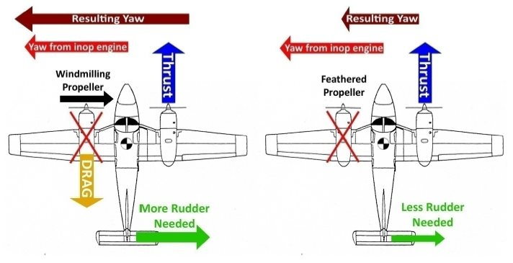
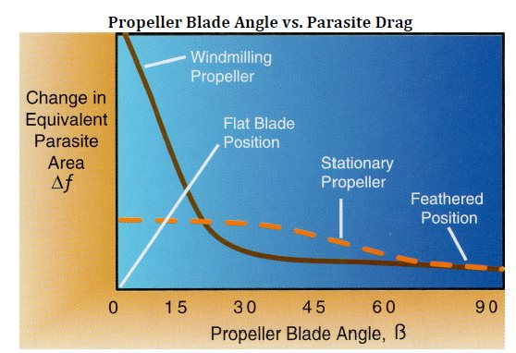

A windmilling propeller decreases performance due to the parasite drag created by the propeller blades.
FLAP POSITION

When the flaps are down the wings create more lift than if the flaps were up. However, when lift is created, drag is also created (as lift increase, drag increases).

The side with the operating engine is creating even more lift because of the accelerated air flowing over the wing. When the flaps are extended, the drag caused by the accelerated flow opposes the yaw caused by the inoperative engine allowing the pilot to use less rudder deflection to maintain heading. Having more rudder authority available to the pilot lowers V_{MC}.

It should be noted more lift on the right wing will cause a roll to the left. If ailerons are used to counteract the rolling of the airplane, the drag from the adverse aileron yaw will actually increase the yaw towards the inoperative engine.

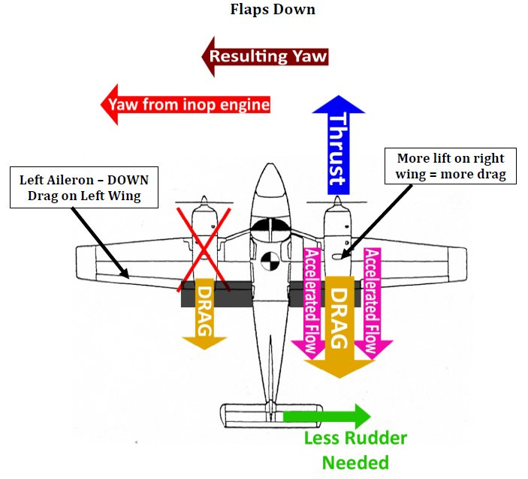
GROSS WEIGHT

The weight of the airplane determines the amount of total lift required by the airplane to maintain level flight. As the airplane is banked, the lift is separated into horizontal and vertical components of lift.

The horizontal component of lift (the force that causes the airplane to turn) will help oppose the yaw due to an inoperative engine. The more weight, the more horizontal lift is available to oppose the turn from the inoperative engine.

This means that horizontal lift can be used along with rudder to stop the turn. When more horizontal lift is available, less rudder deflection is needed, which means more rudder authority is available to the pilot and VMC decreases. So, as weight increases, VMC speed decreases. As weight decreases, VMC increases.

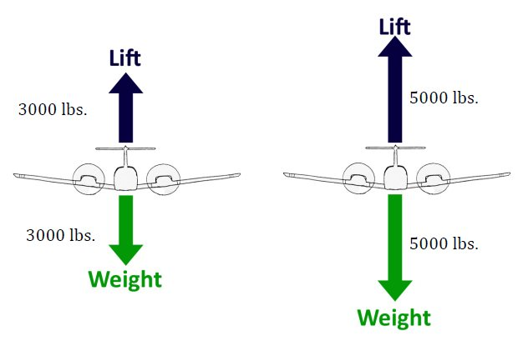

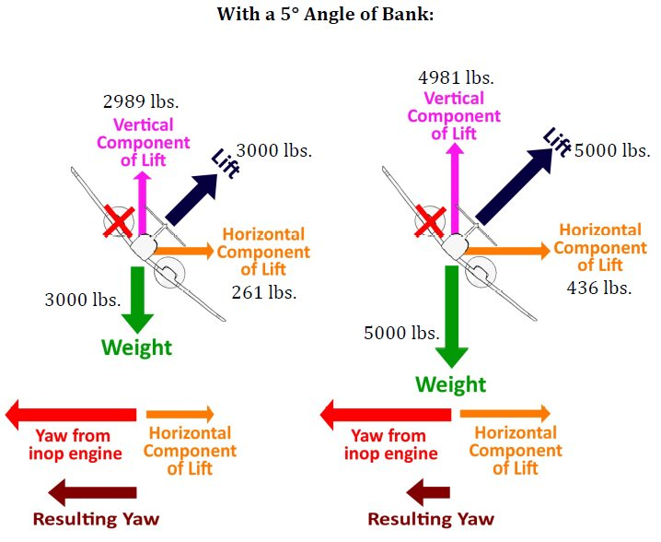
The larger horizontal component of lift on the heavier airplane will make the resulting yaw smaller. This also reduces the amount of rudder needed to maintain the airplane’s heading.
A higher weight always lowers performance because it decreases the amount of excess thrust available. This is especially true during one‐engine inoperative operations.

Fuel consumption will also lower the weight of an aircraft during flight, increasing VMC and airplane performance. The amount it affects weight depends on the rate at which the fuel is consumed.

2°-3° BANK TOWARD OPERATING ENGINE

In this example, both rudder and a small amount of bank are used to maintain a constant heading.

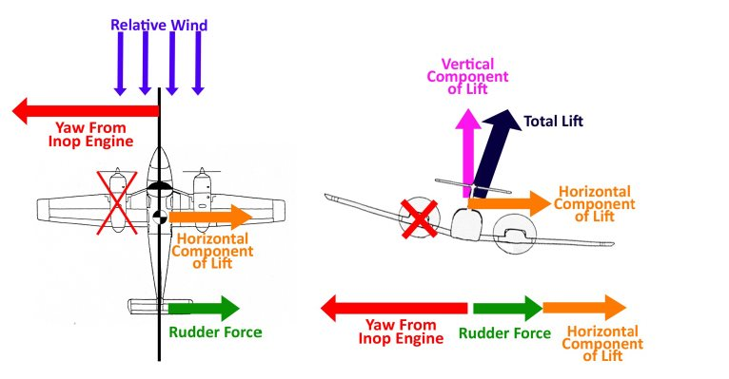
This bank angle and rudder combination results in a Zero Sideslip condition. A Zero Sideslip condition exists when the relative wind is directly parallel to the longitudinal axis of the airplane. This condition results in the minimum amount drag possible when an engine is failed.

V_{MC} speed will be lower in this case (compared to 0° bank) for two reasons:
1. The angle of attack on the rudder is larger making it more effective.
2. The amount of rudder needed and used is less than in the 0° of bank scenario since it is more effective. Also, the horizontal component of lift is now helping to oppose the yaw from the inoperative engine (meaning less rudder deflection will be required).

The result is more rudder authority is available to the pilot, which will lower V_{MC}.

Performance will increase due to the smaller amount of drag.

5° BANK TOWARDS INOPERATIVE ENGINE

In this example, the airplane is banked towards the inoperative engine

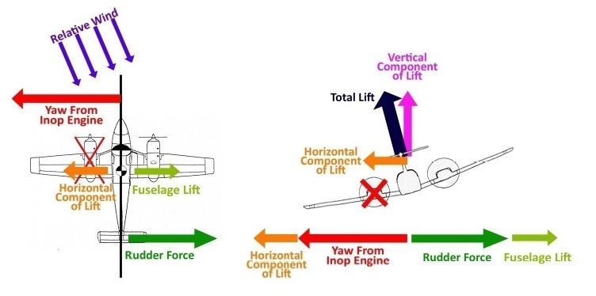
Banking towards the inoperative engine will cause the horizontal lift from the wings to add to the yaw from the inoperative engine. The relative wind will create a fuselage lift that opposes the yaw. The angle of the relative wind with the rudder will create a small angle of attack making the rudder less effective. To maintain heading the pilot will have to use a very large amount of rudder. This increases V_{MC} significantly.

The performance of the airplane will decrease because the angle of the relative wind will result in a slipping condition and cause a large amount of drag on the airplane.

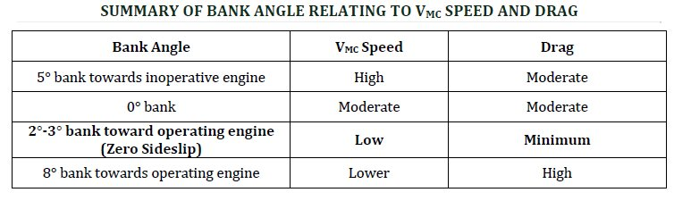

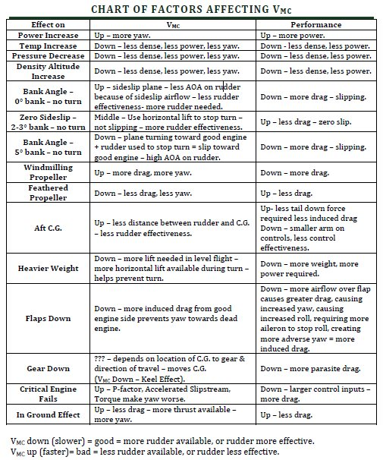

KEY PERFORMANCE NUMBERS

V – Speeds

Multiengine airplanes use the same nomenclature to identify velocities, “V”‐speeds, as single‐engine airplanes. However, multiengine airplanes have additional “V”‐speeds and airspeed indicator markings unique to OEI flight.

Unless otherwise noted, “V”‐speeds given in the AFM/POH/IM apply to sea level pressure, and standard day conditions at the airplane’s maximum certificated takeoff weight.
Performance speeds will vary with aircraft weight, configuration, and atmospheric conditions. A review of some familiar key “V” speeds and several new speeds unique to multiengine airplane operations is provided below.

V_{SO –} 55 KTS – Stall speed in landing configuration (bottom of the white arc).

VMC – 56 KTS - Minimum control speed with the critical engine inoperative. The minimum speed at which directional control can be maintained under a very specific set of circumstances outlined in 14 CFR Part 23, Airworthiness Standards.
- Indicated as a red radial line on most airspeed indicators.
VMC only addresses directional control.

V_{S} – 57 KTS – Stall speed with flaps retracted.

VR – 75 KTS - Rotation speed. The speed at which back‐pressure is applied to rotate the airplane to a takeoff attitude.

VX – 82 KTS - Best angle of climb speed. This is the speed at which the airplane will gain the greatest altitude for a given distance of forward travel. Required climb gradient is normally expressed as feet per nautical mile.

VXSE – 82 KTS - Best angle of climb speed with one engine inoperative.

VSSE – 82 KTS - Safe, intentional one‐engine‐inoperative speed. Originally known as safe single engine speed, it is the minimum speed to intentionally render the critical engine inoperative.
• Required by 14 CFR Part 23, Airworthiness Standards, to be established and published in the AFM/POH.

VY – 88 KTS - Best rate of climb speed. This is the speed at which the airplane will gain the most altitude for a given unit of time, normally expressed in feet per minute.

VYSE – 88 KTS - Best rate of climb speed with one engine inoperative.
• Indicated as a blue radial line on most airspeed indicators.

V_{FE} - 111 KTS – Maximum flaps extended speed. (top of the white arc).

V_{LO} (UP) – 109 KTS - Maximum landing gear retraction speed.

V_{LO} (Down) – 140 KTS – Maximum landing gear extension speed.

V_{LE} – 140 KTS – Maximum landing gear extended speed.

V_{NO} – 169 KTS – Maximum structural cruising speed.

V_{NE} – 202 KTS – Never exceed speed.

V_{A} – 135 KTS – Maneuvering Speed at 3800 pounds.

V_{A} – 112 KTS – Maneuvering speed at 2700 pounds.

Maximum demonstrated crosswind speed 17 KTS.

An important point to note: VMC addresses Directional Control only. If an engine failure occurs below VMC while the airplane is on the ground, there is insufficient airflow crossing the rudder surface to maintain directional control and the takeoff must be aborted. Directional control can only be maintained by promptly closing both throttles and using nose wheel steering and brakes as required to stop the airplane.

After lift-off, the next consideration is to gain altitude as rapidly as possible. After leaving the ground, altitude gain is more important than achieving an excess of airspeed. Experience has shown that excessive speed cannot be effectively converted into altitude in the event of an engine failure. Altitude gives the pilot time to think and react. Therefore, the airplane should be allowed to accelerate in a shallow climb to attain V_{Y}, the best all-engine rate-of-climb speed. V_{Y} should then be maintained until a safe single-engine maneuvering altitude, considering terrain and obstructions, is achieved.

In OEI flight at low altitudes and airspeeds, such as the initial climb after takeoff, pilots must operate the airplane so as to guard against the three major accident factors: (1) loss of directional control, (2) loss of performance, and (3) loss of flying speed. All have equal potential to be lethal

PERFORMANCE AND LIMITATIONS

Accelerate-stop distance is the runway length required to accelerate to a specified speed (either VR or VLOF, as specified by the manufacturer), experience an engine failure, and bring the airplane to a complete stop.

Accelerate-go distance is the horizontal distance required to continue the takeoff and climb to 50’ AGL, assuming an engine failure occurs at VR or VLOF, as specified by the manufacturer (see diagram below).

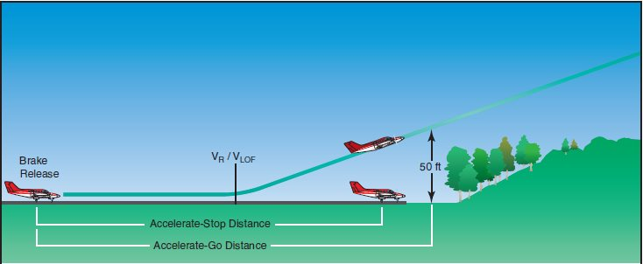

14 CFR Part 91 does not specifically require that the runway length be equal to or greater than the accelerate‐stop distance. Most AFM/POHs publish accelerate‐stop distances only as an advisory. It becomes a limitation only when published in the limitations section of the AFM/POH. Using runway lengths of at least the accelerate‐stop distance is a good operating and safety practice.

ΣΙΝΓΛΕ ΕΝΓΙΝΕ ΧΛΙΜΒ ΠΕΡΦΟΡΜΑΝΧΕ

FAR 23.67 is the regulation that establishes the single‐engine climb performance requirements for airplane manufacturers seeking FAA certification of multiengine aircraft. Specifically;

For aircraft with a maximum weight of 6,000 lbs., or less and a VSO of 61 knots or less:
The single‐engine rate of climb at a pressure altitude of 5,000’ must simply be determined with the—
1. Critical engine inoperative and its propeller in the minimum drag position
2. Remaining engine(s) at no more than maximum continuous power
3. Landing gear retracted
4. Wing flaps retracted
5. Climb speed not less than 1.2VS1

• The rate of climb could be a negative number – meaning a descent
• There is no requirement for a single‐engine positive rate of climb at 5,000 ft., nor any other altitude.

For Aircraft with a maximum weight of 6,000 lbs. or less, and/or VSO more than 61 knots:

If certified before February 4, 1991: the single engine rate of climb in feet per minute at
5,000’ MSL must be equal to at least .027 VSO2 (VSO Squared)

If certified after February 4, 1991: maintain a steady climb gradient of at least 1.5 percent at a pressure altitude of 5,000 ft. with the—

1. Critical engine inoperative and its propeller in the minimum drag position
2. Remaining engine(s) at no more than maximum continuous power
3. Landing gear retracted
4. Wing flaps retracted
5. Climb speed not less than 1.2 VS1

Rate of climb is the altitude gain per unit of time.

Climb gradient is the actual measure of altitude gained per 100 ft. of horizontal travel, expressed as a percentage.
- An altitude gain of 1.5 ft. per 100 ft. of horizontal travel (or 15 ft. per 1,000, or 150 ft. per 10,000) is a climb gradient of 1.5 percent.

ENGINE ALTITUDE LIMITATIONS

All-Engine Service Ceiling ‐ the highest altitude at which the airplane can maintain a steady rate of climb of 100 fpm with both engines operating at full power.

All-Engine Absolute Ceiling ‐ the altitude where climb is no longer possible with both engines operating at full power.

Single-Engine Service Ceiling ‐ the highest altitude at which the airplane can maintain a steady rate of climb of 50 fpm with one engine operating at full power and one engine’s propeller feathered.

Single-Engine Absolute Ceiling ‐ the altitude where climb is no longer possible with one engine operating at full power and one engine’s propeller feathered.

If a multiengine airplane is flying above the single‐engine service ceiling and one engine fails in flight, the airplane will drift down from the failure altitude to the single‐engine absolute ceiling.
• Above the single‐engine absolute ceiling, VYSE yields the minimum rate of sink.
• For example if an airplane’s single‐engine absolute ceiling is 5,000 ft. and while cruising at 9,000 ft. an engine fails, the airplane will drift down (descend) to 5,000 ft. Maintaining V_{YSE} will provide the slowest drift-down (descent) to the single-engine absolute service ceiling.

PIPER PA-44-180 SEMINOLE SYSTEMS

AIRFRAME

The basic airframe is constructed of an aluminum alloy. The fuselage is a semi‐monocoque structure, meaning both the internal supports and the metal skin share the load of the airplane.

The Seminole has an entry/exit door on the forward right (passenger) side of the fuselage, a cargo door on the aft right side of the fuselage, and an emergency egress available through the forward left (pilot) window.

The wings are semi‐tapered and attached to the fuselage by one main spar and two auxiliary (front/rear) spars. The rear spar, in addition to taking torque and drag loads, provides a mount for flaps and ailerons.

ENGINES

The Piper Seminole is powered by two Lycoming four‐cylinder O‐360‐A1H6 engines rated at 180hp at 2700 RPM.

The engines are carbureted, direct‐drive, horizontally opposed, air cooled engines. The right engine model is called a LO‐360‐A1H6, with the L standing for left‐turning. The 360 stands for the number of inches of cubic displacement in the cylinders, and the A1H6 stands as a manufacturer code for the type of accessories used on the engine and the type of propeller mount on the front of the engine.

A useful mnemonic device to use is LHAND:
L – Lycoming O-360-A1H6
H – Horizontally Opposed
A – Air cooled
N – Normally Aspirated
D – Direct Drive

Each engine is equipped with an oil cooler with a low temperature bypass system and engine mounted oil filter. The bypass system only lets oil flow through the oil cooler if the oil is hot enough to need to be cooled.

The oil system can hold a maximum of 6 quarts and can be run on a minimum of 4 quarts.
SkyWarrior requires a minimum of 4.5 quarts before flight. Each engine has its own specific dipstick and they cannot be interchanged. Each dipstick has the words “LEFT ENGINE” or
“RIGHT ENGINE” stamped on it (as shown below).

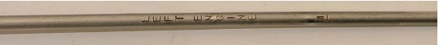

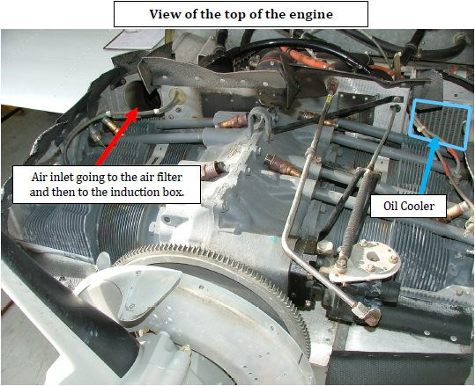

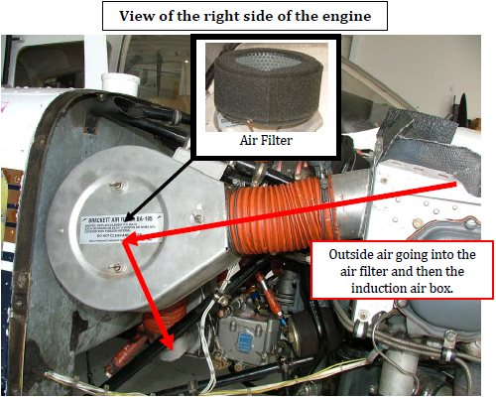

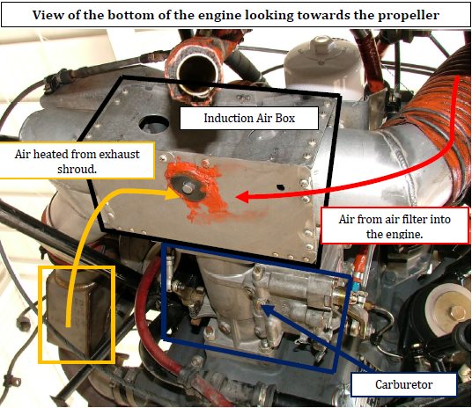

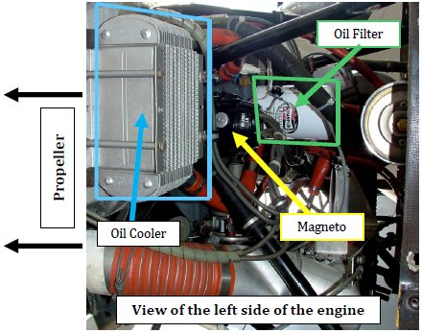

COWL FLAPS

Each engine has a manually operated cowl flap which is used to vary the amount of air flowing through the engine cowling. This air will cool the engine and keep it at normal operating temperatures. The cowl flaps have three positions (open, intermediate, and closed) and must be unlocked by pushing the metal lever in to move the cowl flap lever. Push down to open the cowl flaps, pull up to close.

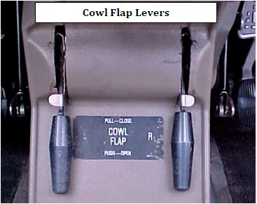

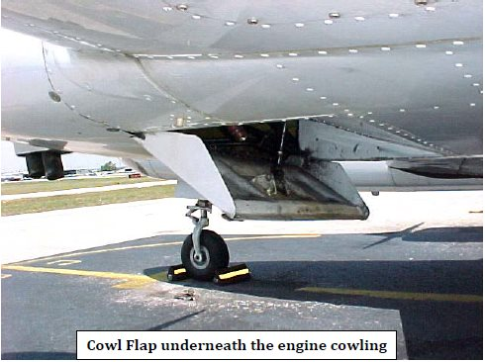

PROPELLERS

The Seminole has counter‐rotating propellers that provide balanced thrust during takeoff and climb and eliminate the critical engine factor in one engine inoperative flight.

The propellers are two‐bladed, constant‐speed, controllable‐pitch and full‐feathering Hartzell propellers. Propeller pitch is controlled by oil pressure, a hub spring, counterweights, and nitrogen pressure. Governors supply engine oil at various pressures to the propeller hub to maintain constant RPM settings. Each governor controls engine speed by varying the pitch of the propeller to match load torque to engine torque in response to changing flight conditions.

Feathering
Feathering is accomplished by moving the propeller control full aft into the detent position.
Feathering takes approximately 10-17 seconds. A feathering lock or centrifugal stop pin, operated by centrifugal force, will prevent feathering during engine shutdown by making it impossible to feather anytime the engine speed falls below 950 RPM. This will prevent excessive loads on the engine starter during the next engine start.
Regardless of the propeller control position, if oil pressure is lost, the propeller will feather when the RPM is above 950 RPM. Typically, RPM will be above 950 in flight and during takeoff and landing due to airflow over the propeller.
Propeller Overspeed
Propeller overspeed is usually caused by a malfunction in the propeller governor, which allows the propeller blades to rotate to full low pitch. If propeller overspeed should occur, retard the throttle. The propeller control should be moved to full “DECREASE RPM” and then set to a normal operating RPM if any control is available. Airspeed should be reduced and the throttle used to maintain a maximum of 2700 RPM.

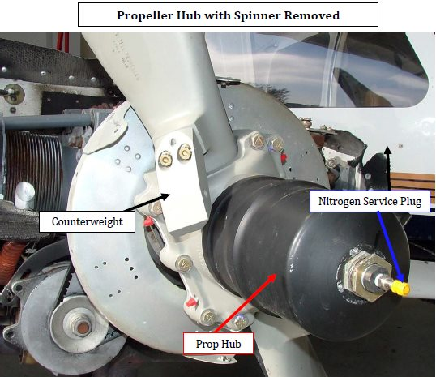

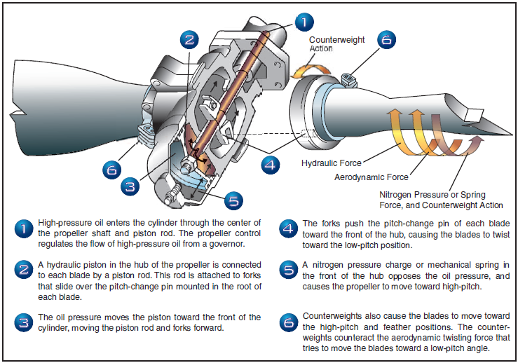

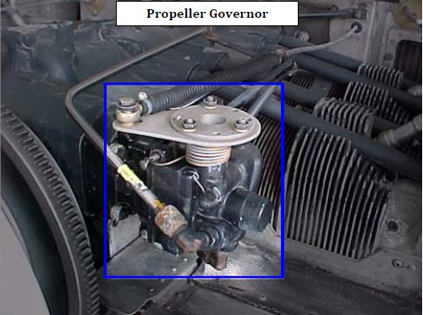

LANDING GEAR

Operation of the landing gear is electrically activated and hydraulically actuated. The landing gear system uses an electric 12‐volt, reversible pump to move hydraulic fluid. The hydraulic fluid flows in and out of an actuator that, in turn, raises and lowers the landing gear.

The landing gear pump is located behind the baggage compartment aft bulkhead (a removable plastic panel). Landing gear extension or retraction takes 6 to 7 seconds.
There are also a series of up‐limit, down‐limit, and squat switches that control the system.
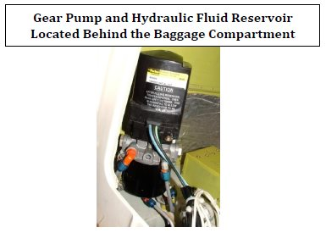
When raising or lowering the landing gear, the hydraulic pump will activate and move hydraulic fluid from one side of each landing gear actuator to the other. This fluid motion moves a piston connected to an actuator rod that is connected to the appropriate main landing gear or nose gear. The main gear actuators are located near the wheels under each wing.

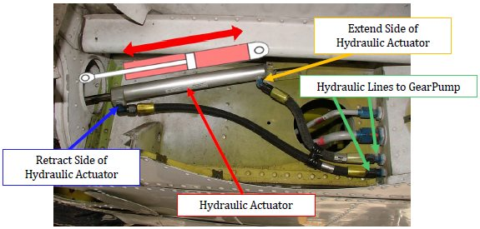

Each main gear and the nose gear has an up‐limit switch and a down‐limit switch to sense gear position. The left main gear has a squat switch. A squat switch determines if the airplane is airborne or still on the ground. The squat switch prevents accidental gear retraction on the ground, and deactivates the stall warning horn. When the gear is retracted, it is held in the UP position only by hydraulic pressure. When the gear is fully extended (DOWN), it is locked down by a down‐lock (called a “J‐Hook” because of its shape), a spring that keeps tension on the J‐Hook, and an over‐center joint which helps keep the gear down in the event of a side‐loaded landing. There are also mirrors mounted on the engine nacelles to allow visual confirmation that the nose wheel is extended.

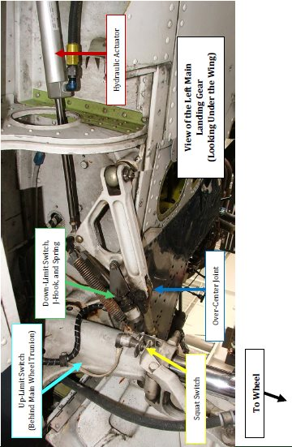
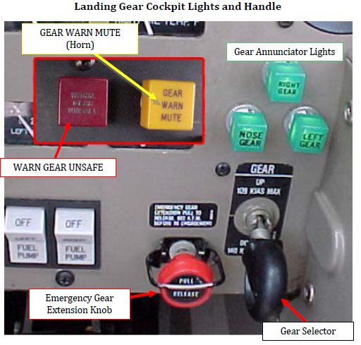
The three green landing gear annunciator lights are illuminated when the down‐limit switches are depressed. The red WARN GEAR UNSAFE light illuminates when any one of the down‐limit switches are not depressed (meaning the gear is not totally down), or up‐limit switches are not depressed (meaning the gear is still in transit and not all the way up). All three of the indicator lights are interchangeable to allow troubleshooting possible landing gear extension problems.

The landing gear warning system is activated under any of the following conditions:
- The landing gear is not locked down with the throttle lever positioned below approximately 15" manifold pressure (MP) on one or both engines.
- The landing gear is not locked down with wing flaps selected to 25˚ or 40˚.
- The landing gear handle is in the up position on the ground (tested only by authorized maintenance personnel).

Landing gear retraction on the ground is prevented by a squat switch located on the left main landing gear. On the ground, the switch is open, preventing electrical current from reaching the hydraulic pump. Once airborne, the strut becomes fully extended, closing the switch that allows current to reach the hydraulic pump.
In the event of a hydraulic malfunction, the landing gear may be extended by the use of the red emergency gear extension knob. After placing the landing gear selector in the down position, pulling the red emergency gear extension knob releases the hydraulic pressure which is holding the landing gear in the up position and allows the landing gear to free-fall down. The positive gear down indication is 3 green lights. Emergency landing gear extension is limited to a maximum of 100 KIAS due to air-load on the nose gear. When dealing with a suspected landing gear problem, it is important to verify the position of the navigation light switch. Turning this switch on will cause the green lights to be dimmed and, in some cases, make them impossible to see during the day. As with any emergency or abnormality, always refer to the appropriate checklist.

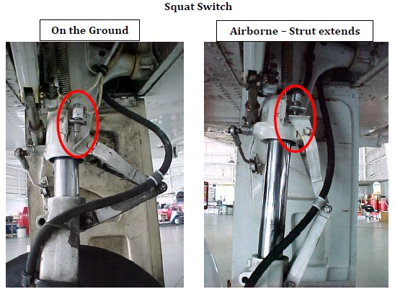
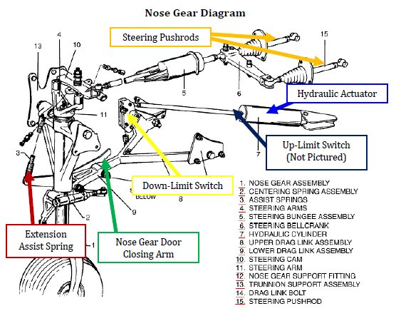

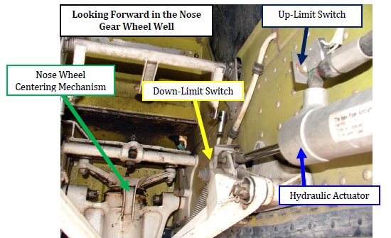
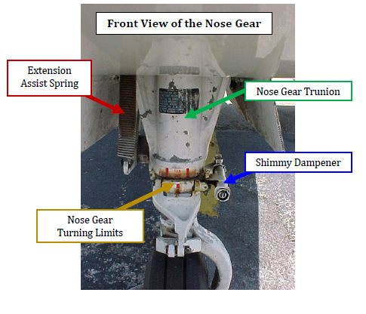
LANDING GEAR OPERATION

To raise the landing gear, the Gear Selector switch must be pulled out slightly and placed (lifted) to the UP position. The hydraulic pump will start and pump fluid into the “retract” side of all three actuators. The down‐locks will disengage, the red WARN GEAR UNSAFE light will illuminate, and the landing gear will be retracted by the hydraulic actuators. The hydraulic pump will continue to operate and build‐up hydraulic pressure until a pressure switch is activated to shut‐off the pump. The red WARN GEAR UNSAFE light will extinguish when all three up‐limit switches are depressed. The up‐limit switches do not turn the gear pump off. The gear is held in the up position only by hydraulic pressure.

To lower the landing gear, the Gear Selector switch is placed in the Down position. The hydraulic pump will start and pump fluid into the opposite side of the three hydraulic actuators.
The landing gear will begin to extend, assisted by gravity and springs. When the up‐limit switches are not depressed, the red WARN GEAR UNSAFE light will illuminate. The landing gear pump will continue to operate until all three down‐limit switches are depressed. The down‐limit switches will also cause the three green landing gear position lights to illuminate. After all three down‐limit switches are depressed, the red WARN GEAR UNSAFE light will extinguish.

Never move the Gear Selector switch in the opposite direction (from Up to Down, or Down to Up) while the hydraulic pump is running. Doing so could damage the gear pump. Wait until the landing gear has finished its extension or retraction cycle completely and then move the Gear Selector switch to the desired position.
If the NAV lights are ON, the landing gear annunciator lights will automatically dim. This may make it difficult to see if all three green lights are illuminated. It is acceptable to briefly turn the NAV lights OFF to verify that the three green lights are illuminated to ensure that the landing gear is down and locked.

LANDING GEAR WARNING HORN

The Seminole has a landing gear warning horn to help prevent unintentional gear up landings. When activated, the horn beeps at 90 cycles per second and the red WARN GEAR UNSAFE light will illuminate.

The landing gear warning horn will sound in the following three scenarios:

- The landing gear is not down and locked, and the manifold pressure (MP) is below 14” on one or both engines. This is accomplished by micro‐switches positioned on the throttle quadrant near the throttles themselves (not from a MP indication). Because the positioning of the micro‐switches are critical to the accuracy of horn actuation, any variation in the location of these switches will cause the gear horn to sound at a MP higher or lower than 14”, as appropriate.
- Flaps are extended to the 25 degrees or 40 degrees, and the landing gear is not down and locked.
- If the Gear Selector switch is in the UP position when the airplane is on the ground.

LANDING GEAR EMERGENCY EXTENSION

If the landing gear does not extend correctly, there is an emergency extension procedure.
Always refer to the proper checklist when conducting this procedure. The emergency extension utilizes a basic pressure relief valve.

The landing gear is held in the UP position by hydraulic pressure. If that pressure is released, gravity will cause the landing gear to free‐fall to the Down position. While the landing gear is extending, the piston in the hydraulic actuator will move the hydraulic fluid into the extension side of the gear actuators.

When using the Emergency Gear Extension control, move the metal guard up and out of the way of the knob and pull the knob out fully. Leave it out fully. Only SkyWarrior Maintenance personnel should push the control knob back in, and only after the landing gear system has been checked. The maximum emergency extension speed is 100 KIAS.

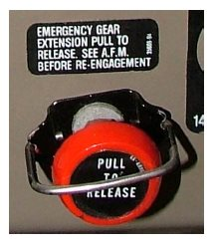

OVERCENTER JOINT

The over‐center joint helps to keep the landing gear fully extended in the event of any side loading during landing. “Over‐center” means that, instead of the joint being in a straight line, it is slightly bent to utilize the force of a side load to help keep the gear down and locked.

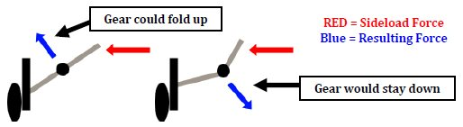

BRAKES

The wheel brakes consist of two single‐disc, double‐puck brake assemblies, one on each main wheel. There are four master brake cylinders, one located behind each rudder pedal.

To set the parking brake, depress the brake pedals first and then pull the parking brake handle up. Setting the parking brake activates a valve that traps hydraulic pressure in the brake lines. Hydraulic fluid for the brakes and the parking brake valve are located in the nose compartment.
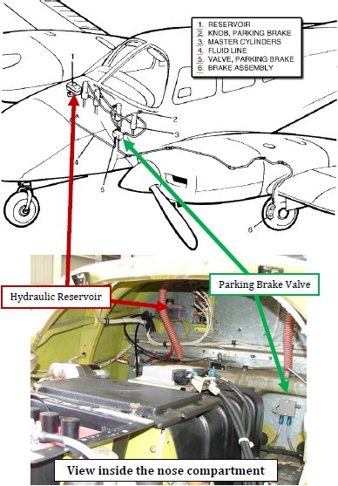

FLAPS

The Seminole incorporates plain flaps that are extended and retracted by a manual flap control handle located between the two front seats. The flaps are extended by a control cable and pushrods with the use of the flap control handle. The flaps can be selected in 4 different positions: 0, 10, 25, and 40 degrees.

The flaps are spring‐loaded to return to the retracted (0°) position. The flap control handle incorporates a button that must be pressed when retracting the flaps. The button does not need to be depressed to extend the flaps. The right flap incorporates a lock to allow the right flap to be used as a step when fully retracted.

The maximum flaps extended speed is 111 KIAS.

FUEL SYSTEM

There are two 55 gallon total fuel cells (54 usable); one in each nacelle (behind each engine). The total capacity is 110 gallons, with 108 gallons of usable fuel. The fuel tanks are made of rubber bladders. There are four fuel vents, one in each fuel filler cap and one under each wing. The vents under the wing feature an anti‐icing design. The curvature in front of the fuel vent disturbs the air and prevents ice from forming on the exposed fuel vent.

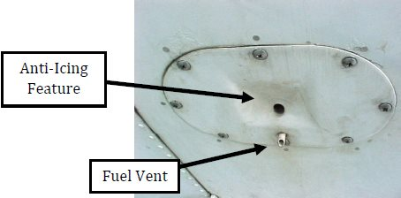

If fuel is spilled by the fuel cap, or if the tank is over filled, a drain called a scupper drain removes the excess fuel. The scupper drain is located underneath the engine on each wing.

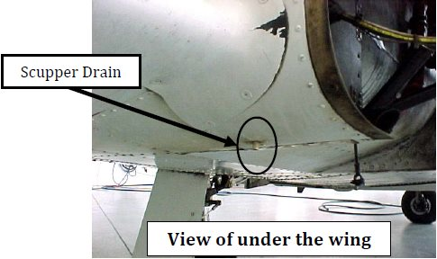

Two fuel drains are located on the right side of the fuselage near the baggage door.
The system also contains two engine‐driven fuel pumps and two electrical fuel pumps. The electric fuel pumps are used during start (priming the engine), takeoff, maneuvering, fuel selector manipulation, and are a backup in case the engine driven pumps fail. When priming the engine only three of the cylinders are primed; the fourth cylinder, where manifold pressure is measured, is not primed. The electric fuel pumps must be on to prime the engine.

The manifold pressure gauge measures the absolute pressure of the fuel/air mixture inside the intake manifold and is more correctly a measure of manifold absolute pressure (MAP). (The intake manifold is the pipe that carries the fuel air mixture to the cylinder from the carburetor).
At a constant rpm and altitude, the amount of power produced is directly related to the fuel/air flow being delivered to the combustion chamber. As the throttle setting is increased, more fuel and air flows to the engine and MAP increases. When the engine is not running, the manifold pressure gauge indicates ambient air pressure (i.e., 29.92 inches of mercury at sea level on a standard day).

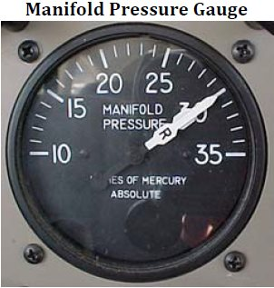

There is a fuel selector for each engine that has a 3‐position switch (ON, OFF, X‐Feed (cross feed). If the left engine fuel selector is ON, fuel will be used from the left tank to the left engine. If the left engine fuel selector is OFF, no fuel will flow to the left engine. If the left engine fuel selector is in the X‐Feed position, fuel will be fed from the right fuel tank to the left engine. The right fuel selector works in a similar way, but with the opposite tank.

The cross feed position should only be used in level flight and then only to keep the fuel load balanced across the airplane (usually in a single engine scenario). In flight, the fuel selectors should never both be in the X‐Feed position. Do not takeoff or land with a fuel selector in the X‐Feed position.

NOTE
When one engine is inoperative and the fuel selector for the operating engine is on X FEED the selector for the inoperative engine must be in the OFF position. Do not operate with both selectors on X FEED. Do not take off or land with a selector on X FEED.

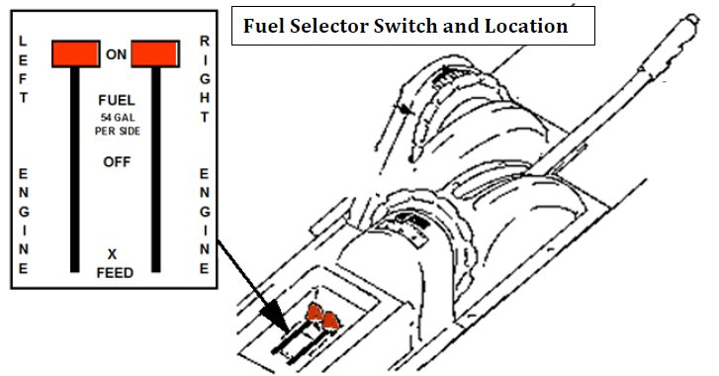

There are two fuel quantity gauges as well as two fuel pressure gauges located on the instrument panel in front of the pilot.

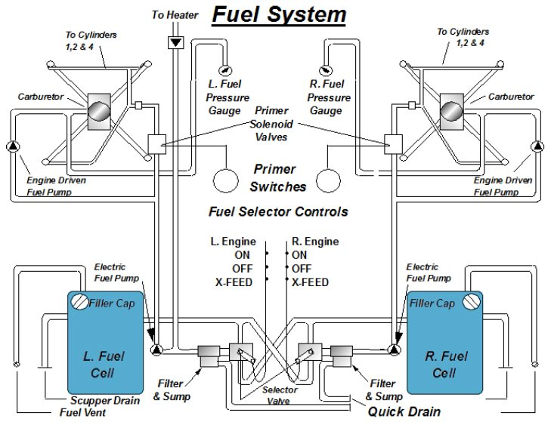

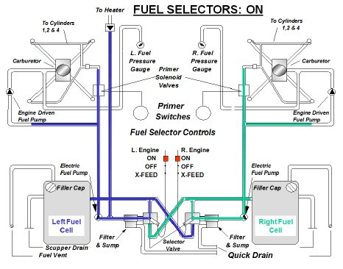
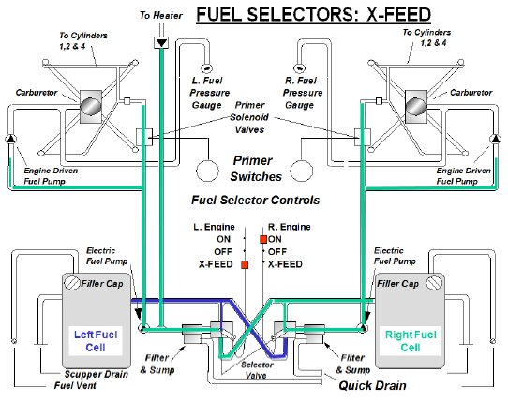

ELECTRICAL SYSTEM

The electrical system is a negative‐ground, dual‐fed, split‐bus system. There are two belt driven,
14‐volt, 60-ampere alternators; one mounted on each engine.

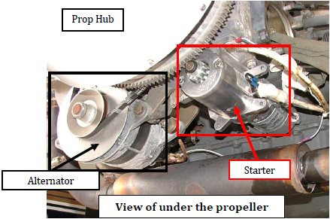

The Seminole is equipped with a 14-volt electrical system which utilizes push-pull type circuit breakers; a 12-volt, 35 amp hour battery; and two 60-amp, engine-driven alternators. Voltage regulators maintain constant 14-volt output from each alternator at varying engine RPMs, effectively sharing the electrical load. Loss of one alternator is indicated by an annunciator light and a zero indication on the affected load meter. The remaining alternator will normally provide adequate electrical power.

An over-voltage relay in each alternator circuit provides system protection by taking an alternator off-line if its output exceeds l7-volts. If this occurs, the ALT annunciator will illuminate. The battery is used as a source of emergency electrical power and for engine starts. High current drain items include the lights, vent fan, heater, gear hydraulic pump, radios, and GPS. If an electrical problem arises, always check the circuit breakers. If a circuit breaker is popped, reset only one time.

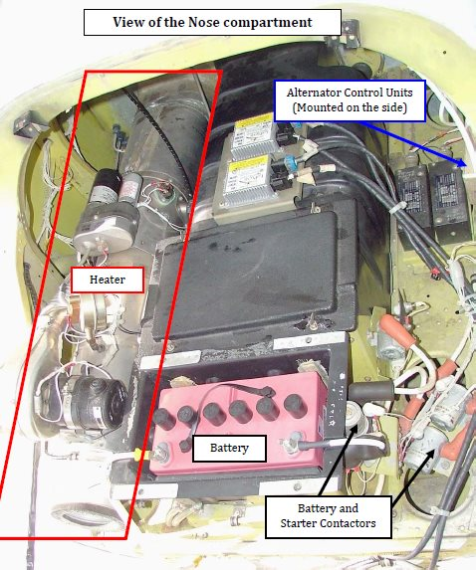

VACUUM SYSTEM

The Seminole is equipped with two engine-driven vacuum pumps. The vacuum system operates the attitude gyro and the directional gyro element of the HSI. Suction limits are 4.8 to 5.2 inches of mercury at 2000 RPM. The failure of a vacuum pump is indicated by an annunciator panel light and a red, pump inoperative indicator on the vacuum gauge. In most circumstances, the failure of one pump alone will not cause the loss of any instruments because the remaining pump should handle the entire vacuum demand.

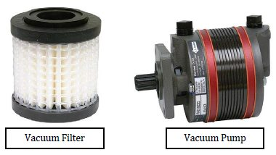

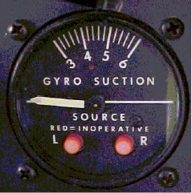

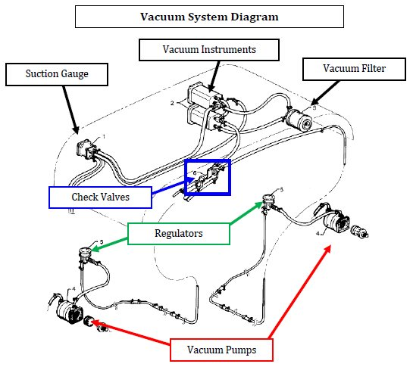

PITOT STATIC SYSTEM

The pitot static system supplies pitot and static pressure to the airspeed indicator and static pressure to the altimeter, vertical speed indictor, and blind encoder. (The blind encoder is what sends the altitude of the airplane to ATC.)

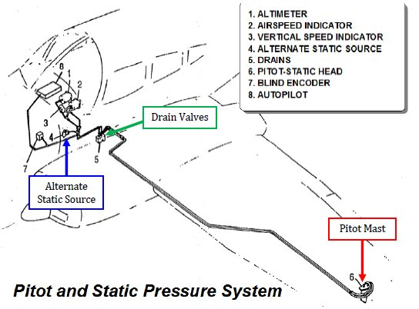
The pitot and static lines can be drained of water through drain valves located inside the cabin to the left of the pilot seat near the floor. To drain press the buttons in and any water in the lines will drain out the middle of the button.

An alternate static source located under the left side of the instrument panel will allow air from inside the cabin for static pressure. The cabin vents and storm window must be closed and the cabin heat and defroster must be on when using the alternate static source.

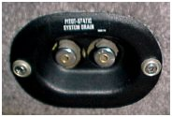

The pitot mast is also heated for de‐icing or anti‐icing if unintentionally encountering icing conditions in flight.

ENVIRONMENTAL SYSTEM

The environmental system provides both fresh outside air and heated air for cabin heat and defrosters. There is an air blower near the tail of the airplane and a Janitrol combustion heater, which is located in the nose compartment of the airplane.

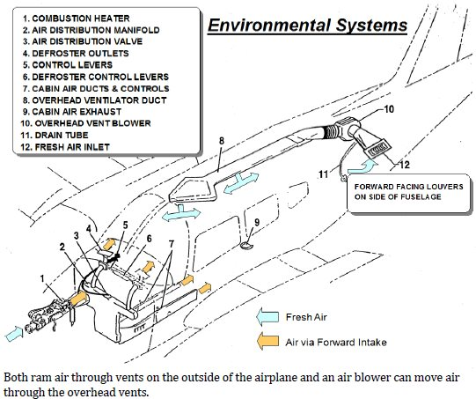

COMBUSTION HEATER

Heat to the cabin is supplied by either a Janitrol or a Kelly gas combustion heater located in the nose compartment. Air from the heater is distributed by a manifold to the ducts along the cabin floor to outlets at each seat and to the defroster outlet. Operation of the heater is controlled by a three-position switch located on the instrument panel labeled “CABIN HEAT”, “OFF”, and “FAN.” Airflow and temperature are regulated by the three levers to the right of the switch: “AIR INTAKE”, “TEMP”, and “DEF.”
For cabin heat, the “AIR INTAKE” lever must be fully open and the “CABIN HEAT” switch on. This simultaneously starts fuel flow and ignites the heater. During ground operation, it also activates the ventilation blower. When cabin air reaches the temperature selected on the “TEMP” lever, ignition of the heater cycles automatically to maintain the selected temperature.
Two safety switches located on the front of the heater unit prevent both fan and heater operation when the air intake lever is in the closed position. When the heater is on, a ventilation blower actuates any time the landing gear is extended. In flight, a micro switch, which actuates when the gear is retracted, turns off the ventilation blower so that the cabin air is circulated by ram air pressure only.
An overheat switch in the heater acts as a safety device to render the heater inoperative if a malfunction should occur. Should the switch deactivate the heater, the red “HEATER OVER TEMP” annunciator light on the instrument panel, will illuminate. The overheat switch is located on the aft inboard end of the heater vent jacket. A red reset button is located on the heater shroud in the nose cone compartment.
To prevent activation of the overheat switch upon normal heater shutdown during ground operation, turn the three-position switch to “FAN” for two minutes with the air intake lever in the open position before turning the switch off. During flight, leave the air intake open for a minimum of 15 seconds after turning the switch to off.
Fuel is supplied to the heater at a rate of ½ gallon per hour from downstream of the left fuel selector and filter.

To introduce outside, unheated air into the cabin during flight, the “AIR INTAKE” lever should be open and the “CABIN HEAT” switch off. A fresh air blower is installed to provide airflow during ground operation. It is operated by a high/low blower fan switch.

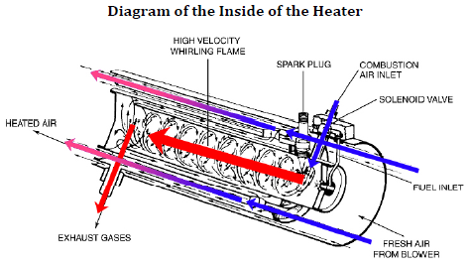

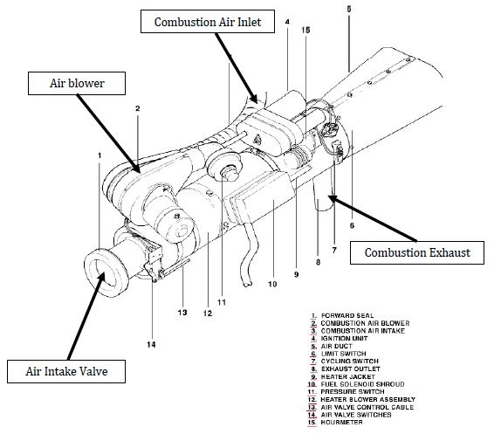
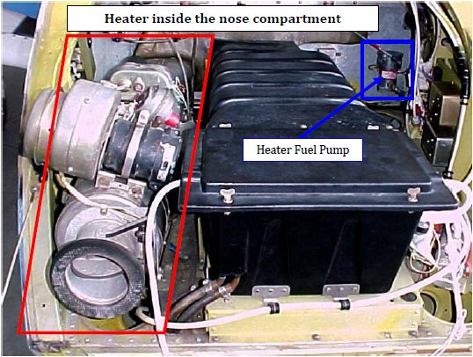

ANNUNCIATOR PANEL AND WARNING LIGHTS

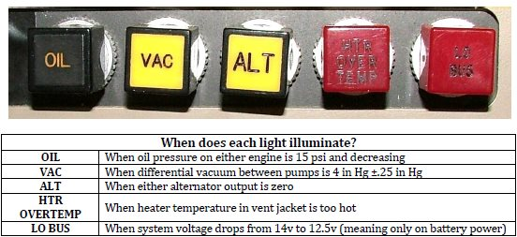

STALL WARNING SYSTEM

Stall warning vanes on the left wing are enabled by the squat switch once the airplane is airborne. They cause an aural warning when airplane is approximately 5‐10 knots above stall speed. The outboard stall warning vane operates when flaps are set at 0 or 10 degrees. The inboard stall warning vane operates when the flaps are set at 25 and 40 degrees.

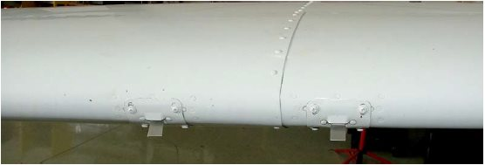

EMERGENCY EXIT

The left window can be removed to be used as an emergency exit. To open the exit, remove the plastic cover from over the handle, pull the handle towards the nose of the airplane, and push the window out. The window will then free fall out of the frame. This exit should only be opened and used when on the ground.

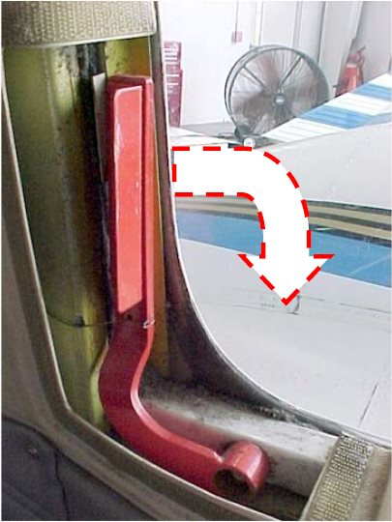

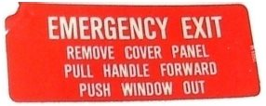

EMERGENCY LOCATOR TRANSMITTER (ELT)

The ELT is located in the aft fuselage section of the airplane. It runs off its own self-contained battery. The battery must be replaced after 1 hour of cumulative use, after it has been used in an emergency situation, or after the replacement date on the battery, which is half the shelf life of the battery. It can be tested during the first 5 minutes after the hour for no more than 3 audio sweeps. There is an automatic G‐switch that will turn on the ELT after a hard landing or a crash, and a remote switch located on the instrument panel that can turn on the ELT anytime.

PROCEDURES AND MANEUVERS

Piper Seminole Procedures

Pre-maneuver Checklist
- Fuel Selectors- on
- Fuel pumps- on
- Landing light- on
- Props- Full Forward (for maneuvers such as stall recoveries that require full power)

Steep Turns
- Clearing turns - Complete
- Pre-maneuver checklist - Complete
- Power-18”/2300 RPM (110 knots)
- Note target heading
- Roll into a left 360 turn at a 45 degree bank
- 30 degree bank pitch up slightly and add 1”-2” MP
- Roll out ( lead by ½ the degree bank angle)
- Pitch down to horizon and decrease power 1”-2” MP
- Repeat right 360 turn

Approach to stall in Landing Configuration (landing gear down; full flaps)
- Clearing turns complete (entry altitude at or above 4,000 feet AGL)
- Pre-maneuver checklist complete
- Note target heading
- Power 15 “MP
- Landing Gear down (below 140 knots)
- Flaps down (111 knots)
- Maintain heading and altitude
- Recover at first indication of stall
- Power- Full
- Pitch to reduce angle of attack
- Flaps- retract to 25 degrees
- Landing Gear up
- Retract remaining flaps in increments, after establishing a positive rate of climb
- Level off at 110 knots (18’/ 2300 RPM)

Approach to stall in Approach Configuration (landing gear down; 25 degrees flaps)

1. Clearing turns complete (entry altitude at or above 4,000 feet AGL)
- Pre-maneuver checklist complete
- Note target heading
- Power 15 “MP
- Landing Gear down (below 140 knots)
- Flaps down to 25 degrees (111 knots)
- Maintain Heading and Altitude
- Recover at first indication of stall
  - Power- Full
  - Pitch to reduce angle of attack
  - Landing Gear up
  - Retract flaps in increments, after establishing a positive rate of climb
  - Level off at 110 knots (18”/ 2300 RPM)

Approach to stall in the Clean/Cruising Configuration (15-30° angle of bank turn)

- Clearing turns complete (entry altitude at or above 4,000 feet AGL)
- Pre-maneuver checklist complete
- Note target altitude
- Power- 15 “MP
- Bank- 15°-30°
- Pitch- maintain altitude
- Recover at first indication of stall
  - Lower nose to horizon
  - Power- full
  - Wings- Level
  - Level off at 110 knots (18”/ 2300 RPM)

Recovery from Unusual Attitudes

- Clearing turns complete (entry altitude at or above 4,000 feet AGL)
- Pre-maneuver checklist complete

Nose Low Recovery
- Power – idle
- Wings – level
- Pitch – up to horizon

Nose High Recovery
- Pitch – down to horizon
- Power – full
- Wings – Level

V_{MC} Demonstration *(only if required)*

- Clearing turns complete
- Pre-maneuver checklist complete
- Landing gear and flaps up
- Airspeed at or above 82 KIAS (VSSE)
- Reduce power to idle on the left engine (simulating the loss of the critical engine in a conventional light twin)
- Add full power on the right engine
- Maintain heading with rudder
- Bank up to 5 degrees into the operating engine
- Pitch up to slow the airspeed at approximately 1 knot per second
- Recover at first indication of a stall or loss of directional control
- Reduce power to idle on the right engine
- Pitch down to gain airspeed (at least 82 KIAS) and regain directional control/prevent stall
- Power full on right engine
- Pitch for 88 KTS (approx. level flight), match throttles at 18” of MP and return to cruise flight

Seminole Power Settings

Throttles Props

Take off: Full Forward Full forward

Cruise Climb: 25 inches MP 2500 RPM

Cruise: 21 inches MP 2400 RPM

Maneuvers: 18 inches MP 2400 RPM

Steep turns: 21-22 inches MP 2400 RPM

Stalls: 15 inches of MP Full forward

Instrument Approaches
Precision

Two Engines One Engine

Throttles Props Throttles Props

21 inches MP 2400 RPM 21 Inches MP Full forward
(To glide slope intercept)

17 inches MP Full forward 20 inches MP Full forward
(At glide slope, gear down and 25° flaps) (At glide slope, gear down 0° flap)

Note: pitch nose down 2° for 100 Knots on two engines. Pitch 5° down on one to achieve 100 knots with one engine.

Instrument Approaches
Non-Precision

Two Engines One Engine

Throttles Props Throttles Props

15 inches Full forward 18 inches Full forward
(At FAF with 25 degrees flaps) (At FAF with 0 degrees flaps)

Note: Pitch 5° down for both or single engine to achieve 100 knots
Note: Two miles before FAF pilot needs to select gear down

Normal Landing Pattern

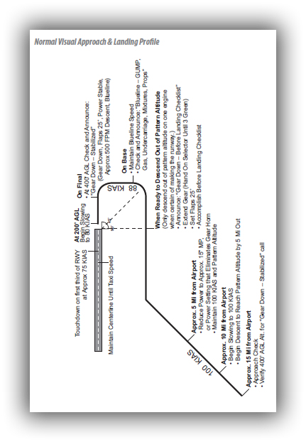

Garmin 430 Quick Reference

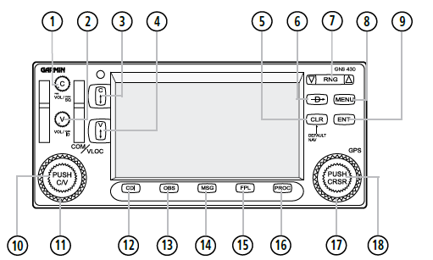

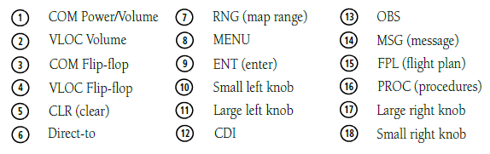

Left-hand Keys and Knobs
The COM Power/Volume Knob controls unit power and communications radio volume. Press momentarily to disable automatic squelch control. The VLOC Volume Knob controls audio volume for the selected VOR/Localizer frequency. Press momentarily to enable/disable the ident tone. The large left knob is used to tune the megahertz (MHz) value of the standby frequency for the COM transceiver or the VLOC receiver, whichever is currently selected by the tuning cursor. The small left knob is used to tune the kilohertz (kHz) value of the standby frequency for the COM transceiver or the VLOC receiver, whichever is currently selected by the tuning cursor. Press this knob momentarily to toggle the tuning cursor between the COM and VLOC frequency fields.
The COM Flip-flop Key is used to swap the active and standby COM frequencies. Press and hold to select emergency channel (121.500 MHz). The VLOC Flip-flop Key is used to swap the active and standby VLOC frequencies (i.e., make the selected standby frequency active).

Right-hand Keys and Knobs
The RNG Key allows the pilot to select the desired map range. Use the up arrow of the key to zoom out to a larger area, or the down arrow to zoom in to a smaller area. The Direct-to Key provides access to the direct-to function, which allows the pilot to enter a destination waypoint and establishes a direct course to the selected destination. The MENU Key displays a context-sensitive list of options. This options list allows the pilot to access additional features or make settings changes which relate to the currently displayed page. The CLR Key is used to erase information, remove map detail, or to cancel an entry. Press and hold the CLR key to immediately display the Default NAV Page. The ENT Key is used to approve an operation or complete data entry. It is also used to confirm information, such as during power on. The large right knob is used to select between the various page groups: NAV, WPT, AUX, or NRST. With the on-screen cursor enabled, the large right knob allows the pilot to move the cursor about the page. The large right knob is also used to move the target pointer right (turn clockwise) or left (counterclockwise) when the map panning function is active. The small right knob is used to select between the various pages within one of the groups listed above. Press this knob momentarily to display the on-screen cursor. The cursor allows the pilot to enter data and/or make a selection from a list of options. The small right knob is also used to move the target pointer up (turn clockwise) or down (counterclockwise) when the map panning function is active.

Bottom Row Keys
The CDI Key is used to toggle which navigation source (GPS or VLOC) provides output to an external HSI or CDI. The OBS Key is used to select manual or automatic sequencing of waypoints. Pressing the OBS Key selects OBS mode, which retains the current ‘active to’ waypoint as the navigation reference even after passing the waypoint (i.e., prevents sequencing to the next waypoint). Pressing the OBS Key again returns the unit to normal operation, with automatic sequencing of waypoints. When OBS mode is selected, the pilot may set the desired course to/from a waypoint using the ‘Select OBS Course’ pop-up window, or an external OBS selector on the HSI or CDI. The MSG Key is used to view system messages and to alert the pilot to important warnings and requirements. The FPL Key allows the pilot to create, edit, activate, and invert flight plans, as well as access approaches, departures, and arrivals. A closest point to flight plan feature is also available from the FPL Key. The PROC Key allows the pilot to select and remove approaches, departures, and arrivals from the flight plan. When using a flight plan, available procedures for the departure and/or arrival airport are offered automatically. Otherwise, the pilot may select the desired airport, then the desired procedure.

To Power on the GNS 430
- Turn the COM Power/Volume Knob clockwise to turn the unit power on and set the desired radio volume.
- A welcome page appears briefly while the unit performs a self-test, followed sequentially by the Unit Type Page and the Software Versions Page. Then (depending on configuration) the Weather Page, the Traffic Page, the Aviation Data Page, the Land/Terrain/Obstacles database Page, and the Situational Awareness Page are sequentially displayed.
- Once the self-test concludes, the Database Confirmation Page is displayed, showing the effective and expiration dates of the Jeppesen database on the NavData® card. Press the ENT Key to acknowledge the Database Page and proceed to the Instrument Panel Self-test Page.

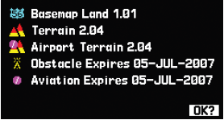

- The Instrument Panel Self-test Page allows the pilot to verify that the GNS 430 is communicating properly with in-panel instruments. Compare on-screen indications with the information depicted on connected instruments, such as the CDI, HSI, RMI, and/or external annunciators. After verifying proper operation, press the ENT Key to display the Satellite Status Page.

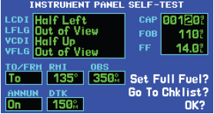

SCREEN LAYOUT (WINDOWS)
The GNS 430’s display is divided into three separate ‘windows’ (or screen areas). The left 1/4 of the display provides a COM window (top two lines) and a VLOC window (bottom two lines). The right 3/4 of the display consists of a GPS window, which shows the various navigation, waypoint information and settings ‘pages’.
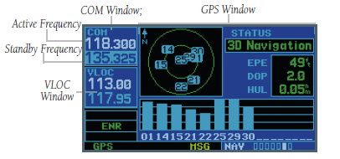
Each unique screen of information is referred to as a page. Pages are typically selected using the small and large right knobs, with the cursor removed from the GPS Window.

CURSORS
There are two separate cursors: a tuning cursor and a GPS window cursor. The tuning cursor is used to select the standby COM or VLOC frequency. If desired, press the small left knob to move the tuning cursor to VLOC Window. Then, use the small and large left knobs to select the desired frequency. The COM Flip-flop and VLOC Flip-flop keys are used to activate the selected frequency.

FREQUENCY SELECTION
If the tuning cursor is not currently in the desired window (COM or VLOC), press the small left knob momentarily. 2) Turn the large left knob to select the desired megahertz (MHz) value. For example, the ‘117’ portion of the frequency ‘117.80’.
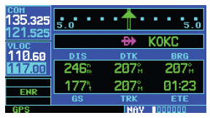
Turn the small left knob to select the desired kilohertz (kHz) value. For example, the ‘.80’ portion of the frequency ‘117.80’.

To activate the selected frequency, press the COM Flip-flop Key for COM frequencies, or the VLOC Flip-flop Key for VLOC frequencies.

DATA ENTRY
Data is entered in the GPS Window using the large and small right knobs. The large right knob is used to move the cursor about the page. The small right knob is used to select individual characters for the highlighted cursor location.

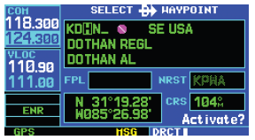

Main Page Groups
The GNS 430’s main pages are divided into 4 separate page groups: NAV, WPT, AUX, and NRST. Each page group is comprised of multiple pages. The page groups are selected using the large right knob. The individual pages are selected using the small right knob.
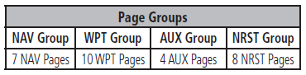

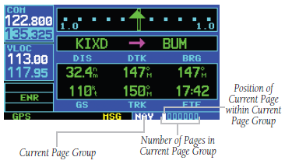
The bottom right corner of the screen indicates which page group is currently being displayed (e.g., NAV, WPT, AUX, or NRST), the number of screens available within that group (indicated by the square icons), and the placement of the current screen within that group (indicated by a highlighted square icon).

To select the desired page group
Press and hold the CLR Key to select the Default NAV Page. Turn the large right knob to select the desired Page Group.

To select the desired page
Turn the small right knob to select the desired page.

To select a direct-to destination
Press the Direct-to Key. The Select Direct-to Waypoint Page appears, with the waypoint identifier field highlighted.

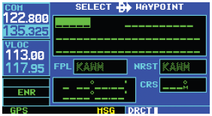

Use the small and large right knobs to enter the identifier of the desired destination waypoint.

Press the ENT Key to confirm the selected waypoint, and press the ENT Key again to activate the direct-to function.

Default NAV Page

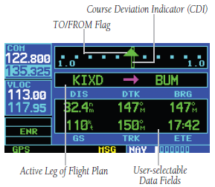

The following symbols are used on the Default NAV Page (directly below the CDI), to depict the ‘active leg’ of a flight plan or direct to:

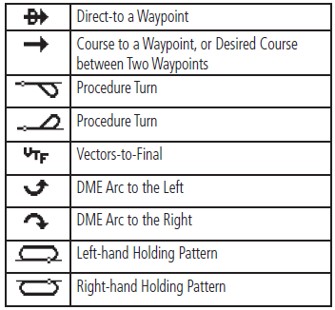

NAV COM Page
The NAVCOM Page provides a list of the airport communication and navigation frequencies at the departure, enroute, and arrival airports.

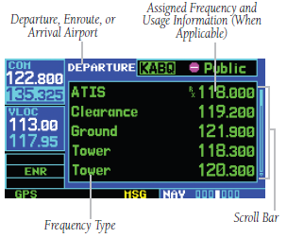
To select a frequency list for a departure, enroute, or arrival airport
Press the small right knob to activate the cursor. Turn the large right knob to place the cursor on the airport identifier field (top line on the NAVCOM Page). Turn the small right knob to select the desired airport and press the ENT Key.
To select an approach
Press the PROC Key to display the Procedures Page. Turn the large right knob to highlight ‘Select Approach?’ and press the ENT Key.

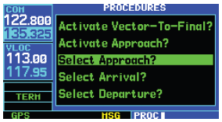

A window appears listing the available procedures. Turn the large right knob to highlight the desired procedure and press the ENT Key.

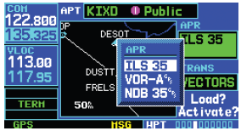

A second window appears listing the available transitions. Turn the large right knob to highlight the desired transition waypoint and press the ENT Key. (The approach ‘Vectors’ option assumes the pilot will receive vectors to the final course segment of the approach and will provide navigation guidance relative to the final approach course.)

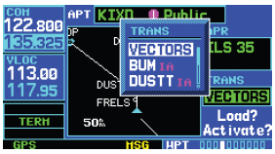

Turn the large right knob to highlight ‘Load?’ or ‘Activate?’ and press the ENT Key. (‘Load?’ adds the procedure to the flight plan without immediately using it for navigation guidance. This allows the pilot to continue navigating the original flight plan, but keeps the procedure available on the Active Flight Plan Page for quick activation when needed.) For precision approaches and some non-precision approaches, a reminder window appears indicating that GPS guidance on such approaches
is strictly for monitoring only — use the VLOC receivers and external CDI (or HSI) for primary navigation. To confirm this reminder, highlight ‘Yes?’ and press the ENT Key.

For a copy of the complete GNS 430 Quick Reference Guide or GNS 430 Pilots Guide you can the Garmin Website at Http//:WWW.Garmin.com. Select the Support icon, then manuals, then aviation, and finally discontinued. Both the Quick Reference Guide and the Pilots Guide are available for download free of charge.

